Conor Oberst Releases New Track “Governor’s Ball” – Stream Now
Reveals Cover Art for Upside Down Mountain - Out on May 19th
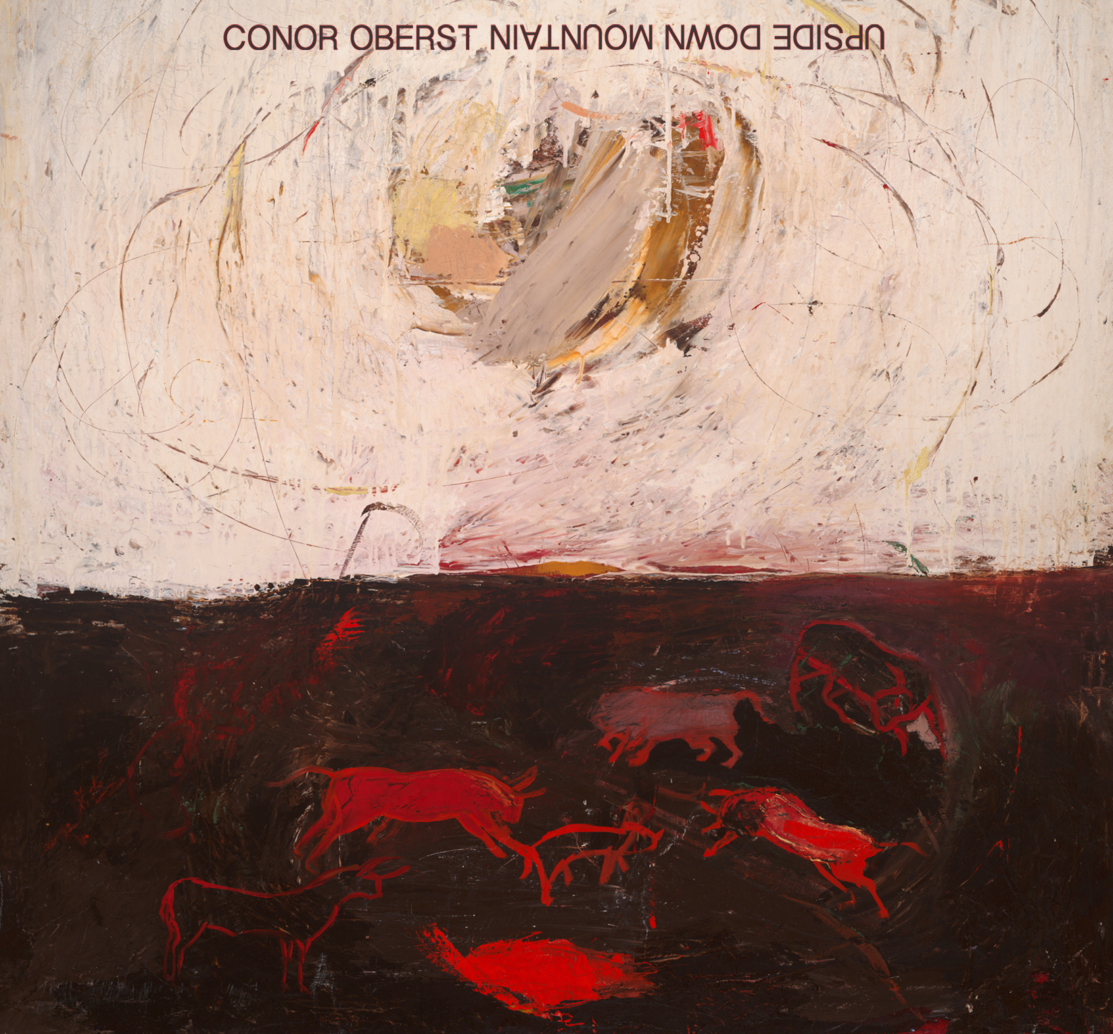

Today, singer-songwriter Conor Oberst revealed the cover art—The Creation of the Bulls by his friend Ian Felice — for his new solo record Upside Down Mountain, which is out on May 19th via Nonesuch Records. PRESS HERE to stream a new album track, “Governor’s Ball.” Pre-order the album at Nonesuch.com, which will include an exclusive print featuring the album art, or via iTunes. All pre-orders include an instant download of “Hundreds of Ways” and “Governor’s Ball.”

Upside Down Mountain features many other friends of Oberst’s, including producer Jonathan Wilson, engineer Andy LeMaster, bassist Macey Taylor, multi-instrumentalist Blake Mills, and the Swedish sibling folk-rock vocal duo First Aid Kit. What started as exploratory demos with producer-musician Jonathan Wilson at his Fivestar Studios in the Echo Park neighborhood of Los Angeles, in a home Wilson rents from Oberst, became the first de facto album sessions. Returning to his native Omaha, Nebraska, Oberst kept rolling with the help of frequent collaborator, engineer, and friend Andy LeMaster at his own ARC Studios. Even more tracking followed in Omaha last November and December. Then Oberst and Wilson moved south to Blackbird Studio in Nashville.

“This is a return to an earlier way I wrote,” Oberst says of the songs on Upside Down Mountain,. “It’s more intimate or personal, if you will. Even if all my songs come from the same place, you make different aesthetic decisions along the way. For me, language is a huge part of why I make music. I’m not the greatest guitar player or piano player—I’m not the greatest singer, either—but I feel if I can come up with melodies I like that are fused with poetry I’m proud of, then that’s what I bring to the table. That’s why I’m able to do this.”

Oberst kicks off the first leg of a world tour in support of the new album on May 8th in North Carolina. His friends and colleagues Dawes appear on the bill as “Special Guests” – both opening the shows and acting as Oberst’s band for the tour. For more information visit http://www.conoroberst.com.

Prior to the album release, a limited-edition seven-inch single will be released exclusively for Record Store Day (Saturday, April 19th). This special single will feature album track “Hundreds Of Ways” along with album outtake “Fast Friends” on the B-side. Press Here to stream “Hundreds Of Ways”.

The track listing for Upside Down Mountain is as follows:

1. Time Forgot
2. Zigzagging Toward The Light
3. Hundreds of Ways
4. Artifact #1
5. Lonely At The Top
6. Enola Gay
7. Double Life
8. Kick
9. Night At Lake Unknown
10. You Are Your Mother’s Child
11. Governor’s Ball
12. Desert Island Questionnaire
13. Common Knowledge

CONOR OBERST WITH SPECIAL GUEST DAWES TOUR DATES:
May 8 Saxapahaw, NC @ Haw River Ballroom
May 9 Asheville, NC @ The Orange Peel
May 10 Atlanta, GA @ Shaky Knees Festival
May 11 Charleston, SC @ Charleston Music Hall
May 13 Ponte Vedra, FL @ Ponte Vedra Concert Hall
May 14 Orlando, FL @ The Beacham
May 16 Gulf Shores, AL @ The Hangout Festival
May 17 Chattanooga, TN @ Track 29
May 21 Philadelphia, PA @ Union Transfer
May 22 Westbury, NY @ The Space at Westbury
May 23 Washington, DC @ 9:30 Club
May 24 Washington, DC @ 9:30 Club
May 25 Munhall, PA @ Carnegie Library Music Hall of Homestead
May 27 Cincinnati, OH @ Taft Theatre
May 29 Chicago, IL @ Metro
May 30 Chicago, IL @ Metro (SOLD OUT)
May 31 Milwaukee, WI @ Pabst Theater
June 1 Minneapolis, MN @ First Avenue
June 2 Minneapolis, MN @ First Avenue
June 4 Omaha, NE @ Sokol Auditorium
June 5 Columbia, MO @ The Blue Note
June 6 Nashville, TN @ Ryman Auditorium
June 7 Lexington, KY @ Buster’s
July 29 New York, NY @ Central Park Summer Stage at Rumsey Playfield



For more information, contact: Chloe Walsh or Carina Contreras at Press Here Publicity – 323-556-9752 or 212-246-2640 / chloe@pressherepublicity.com // carina@pressherepublicity.com

