YOLA PREMIERES VIDEO FOR “FARAWAY LOOK” VIA AMERICAN SONGWRITER

WATCH VIDEO HERE: https://youtu.be/jWTwuQ3LeH4

NPR MUSIC ARTIST TO WATCH IN 2019

DEBUT ALBUM WALK THROUGH FIRE, PRODUCED BY DAN AUERBACH, AVAILABLE FEBRUARY 22 ON EASY EYE SOUND

PERFORMANCES AT NY’S ROCKWOOD MUSIC HALL (2/6) + ADDITIONAL DATES ANNOUNCED INCLUDING GRIMEY’S (2/22) AND THE ANALOG AT THE HUTTON (2/23) IN NASHVILLE

“Mesmerizing”

“With a voice that can belt, swoon and sing the blues, she quickly makes clear that you're in rare company”
Rita Houston, WFUV / SLINGSHOT

“Hails from Bristol, England but she sounds like she could be a church-raised Memphis R&B queen”
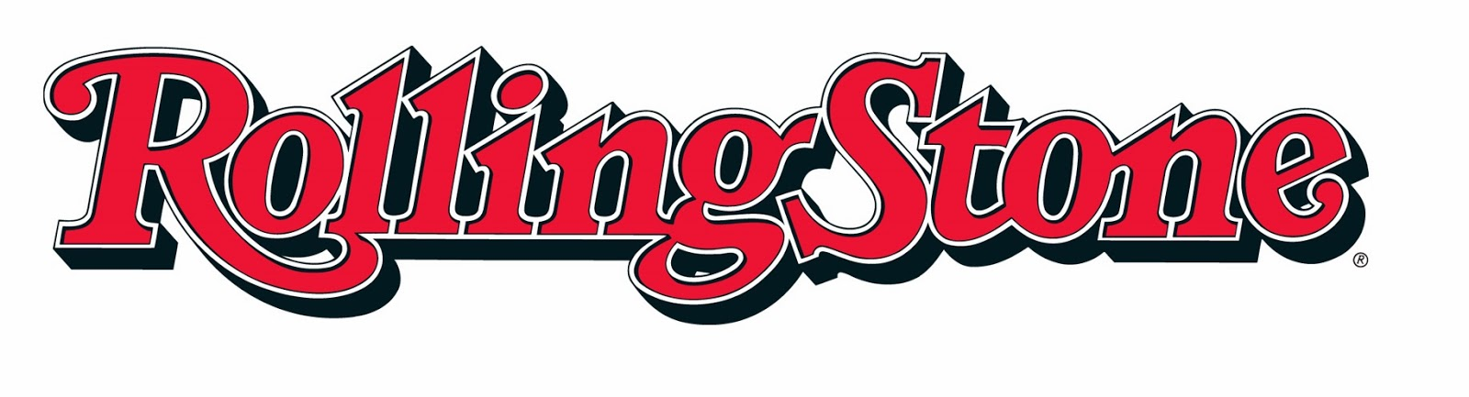
“The gorgeous, breezy vibe of this lead single proves the two make a great pair.”
‘Commanding debut’ ****
“Yola’s debut album, Walk Through Fire – produced by The Black Keys’ Dan Auerbach – should make her unavoidable back home in 2019. There is an irresistible festive magnetism to her vintage soul and gospel-tinged Americana, and songs that feel as if they have been around forever.” - Best New Music of 2019

NASHVILLE TN -- Thursday Jan 17 -- British rising star Yola today premiered the video for “Faraway Look,” the second release from her forthcoming debut solo album, Walk Through Fire, which is produced by The Black Keys’ eight-time Grammy Award winner Dan Auerbach. The album will be released on February 22, 2019 on Auerbach’s Easy Eye Sound label.

The video, directed by Tim Duggan, received high praise from American Songwriter who premiered the video, stating, “the spellbinding video portrays a society eerily transfixed by their electronics.”

Yola said, “My new video has got a faintly Black Mirror feel to it and paints a picture of a society glued to screens. We watch other people live out their dreams as we count down the clock on life and check out from existence.” She continues, “Faraway Look makes me think of a time in my life where I was encouraged to stay in my lane and be thankful for my lot, which it led to a lot of inner reflection. I was beginning to explore being a singer-songwriter and playing guitar live. The people around me at the time, especially those in the music industry, were discouraging to say the least. In a world that questions a woman’s every objection as well as every ambition, the faraway look is king.”

Yola makes her New York debut at Rockwood Music Hall Stage 2 on February 6 and will perform an in-store performance at Grimey’s record store on February 22 and at The Analog at the Hutton on February 23 in Nashville. Tickets will be on sale for The Analog tomorrow AM. For tickets and further information please visit: https://www.iamyola.com/live/.

Dan Auerbach stated, “The moment I met Yola I was impressed. Her spirit fills the room, just like her voice...she has the ability to sing in a full roar or barely a whisper and that is a true gift. She made everyone in the studio an instant believer.”

Yola was an audience favorite when she performed the song on the BBC’s Jools Holland’s Annual Hootenanny on New Year's Eve, alongside other musicians including: Michael Bublé, Jess Glynne, and Nile Rodgers. Check out the performance here: https://youtu.be/FNxR5sNNvv4

Hailing from a small town outside Bristol in the UK, Yola grew up in poverty with an unsupportive parent who “banned” her from making any music. She later became homeless, living on the streets of London, and also experienced stress-induced voice loss. Yola overcame these challenges to launch a successful sideline in writing, perform on pop hits, briefly join British band Massive Attack, and gain fans like the late great James Brown--who once told Yola, “Soul’s a thing, and you got it!” after she opened for him when fronting band Phantom Limb.

Her acclaim continues with an inclusion in NPR Music’s Artists To Watch For 2019 and positive reviews from Brooklyn Vegan and Refinery29 for her recent song “Ride Out in The Country,” alongside inclusions in high profile playlists from Spotify’s Fresh Folk to Rolling Stone Magazine’s monthly playlist. Additional media praise includes early support from the Wall Street Journal, Paste, Stereogum, who have praised Yola’s powerhouse vocals and songwriting, comparing her to a diverse range of artists from the Staples Singers to Dolly Parton.

Written and recorded at Auerbach’s Nashville studio, Easy Eye Sound, Walk Through Fire is a contemporary twist on a traditional sonic tapestry of orchestral strings, fiddle, steel and shimmering tremolo guitars. A truly collaborative record, it was written in the studio by Yola and Auerbach with contributions from songwriting legends who between them have written songs for artists from Glen Campbell to Aretha Franklin. Auerbach also assembled his Easy Eye Sound all-star house band, composed of legendary session players. Musicians who performed on the record include bassist Dave Roe (Johnny Cash) as well as drummer Gene Chrisman and pianist Bobby Wood, who played on hits by Dusty Springfield and Elvis Presley. Guest performers include up-and-comer Molly Tuttle and country music icon Vince Gill.

Yola’s debut album Walk Through Fire is the latest release on Dan Auerbach’s record label, Easy Eye Sound, distributed by his longtime label Nonesuch Records. To pre-order please visit: https://store.easyeyesound.com

Walk Through Fire

- Faraway Look
- Shady Grove
- Ride Out In The Country
- It Ain’t Easier
- Walk Through Fire
- Rock Me Gently
- Love All Night (Work All Day)
- Deep Blue Dream
- Lonely The Night
- Still Gone
- Keep Me Here
- Love Is Light

Produced by Dan Auerbach
Recorded & Engineered by M. Allen Parker at Easy Eye Sound
Mixed by M. Allen Parker and Dan Auerbach at Easy Eye Sound
Mastered by Ryan Smith at Sterling Sound

Credits available on request

www.iamyola.com
https://www.instagram.com/iamyolaofficial/
https://www.facebook.com/iamyolaofficial/
https://twitter.com/iamyola

For more information please contact: Doug Hall | Big Feat PR | doug@bigfeatpr.com | 615 319 0816

For Dan Auerbach enquiries please contact: Mary Moyer | Q Prime | mary@qprime.com

For UK & international enquiries please contact: Matthew Rankin | Nonesuch Records | matthew.rankin@nonesuch.com

