For Immediate Release  May 4, 2015
EMMYLOU HARRIS AND RODNEY CROWELL’S THE TRAVELING KIND
NOW STREAMING EXCLUSIVELY AT NPR MUSIC
NEW ALBUM, PRODUCED BY JOE HENRY, OUT MAY 12 ON NONESUCH
“BRING IT ON HOME TO MEMPHIS” PREMIERES AT BILLBOARD
HARRIS AND CROWELL GAVE SPECIAL PERFORMANCE ON LATE SHOW WITH DAVID LETTERMAN
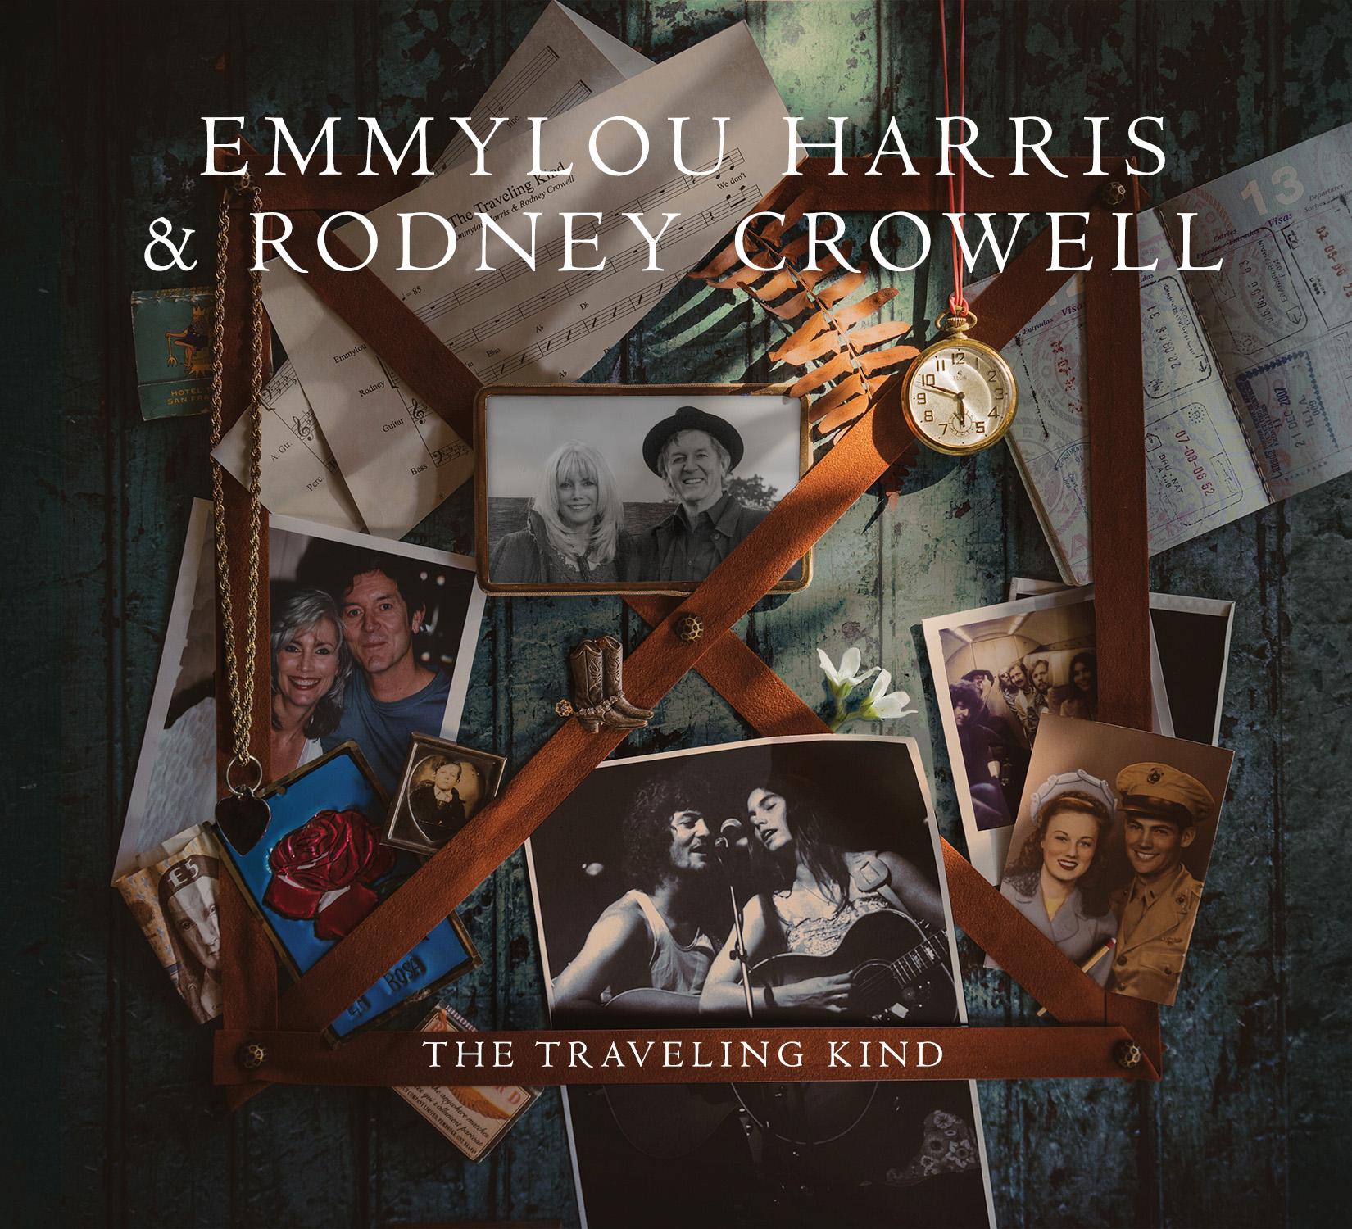
“As they swap lines and leads between his reedy resilience and her gossamer vibrato, Harris and Crowell don’t just share the spotlight. They also share the weight of legacy, influence and lifelong artistic investment, bearing down when the emotional heft of a song calls for it, loosening up and growing playful when it doesn’t, and altogether lightening the load for each other. This is what it sounds like when true equals, both deep into their journeys, draw out the best in each other.”—NPR Music
Emmylou Harris and Rodney Crowell’s second duet album—The Traveling Kind, produced by Joe Henry—is now streaming exclusively at NPR Music as a First Listen. The record will be released next Tuesday, May 12, on Nonesuch Records. Billboard previewed the album’s release in a feature that premieres “Bring It on Home to Memphis”. Additionally, Rolling Stone premiered its title track last month, saying, “‘The Traveling Kind,’ set to a nostalgic, chugging beat, carves the path for the record, which floats from Memphis grooves to classic, country-infused folk ballads, telling stories of love, struggle and the very special art of confessing to both through lyric. … They’ve built their legacies with melodies, lyrics and timeless voices that lace together the most permanent of humanity's living records.”
Prior to a full Australian tour and multiple dates in Europe, Harris and Crowell will play a series of intimate shows in celebration of the record this month, including performances in San Francisco, Napa, Chicago, New York, and Nashville. Complete details are below.
At the host’s request, Harris and Crowell made a special appearance on one of the final episodes of the Late Show with David Letterman last week, performing “Will the Circle Be Unbroken” alongside Steve Martin, Amos Lee, and Mark O’Conner. See the performance here: http://bit.ly/1EK3tXy.
The Traveling Kind follows the longtime friends’ first duet album, 2013’s Old Yellow Moon, which won Best Americana Album at the 56th annual Grammy Awards as well as two awards at the 2013 Americana Music Association Honors & Awards Show, for Album of the Year and Duo/Group of the Year. The album also debuted at #4 on the Billboard’s Top Country Albums chart.
continued
For more information, please contact
Mary Moyer 212.741.1000, Asha Goodman 615.320.7753 or Carla Sacks 212.741.1000,
mary@sacksco.com, asha.goodman@sacksco.com or carla@sacksco.com.
Produced by Grammy Award winner Joe Henry (Billy Bragg, Elvis Costello, Aimee Mann), The Traveling Kind comprises 11 duet tracks, including six new songs written by Harris and Crowell with co-writing by Mary Karr, Cory Chisel, Will Jennings, and Larry Klein. Also featured are new renditions of previous Crowell songs including “No Memories Hanging Around” as well as new interpretations of Lucinda Williams’ “I Just Wanted to See You So Bad” and Amy Allison’s “Her Hair Was Red.” The full track listing is below.
Of the project, Harris comments, “In the words of Willie Nelson, ‘The life I love is making music with my friends,’ and there’s no better friend for me to make music with than Rodney. I can’t wait to get out there on the road with him and play the songs from this new record.”
Crowell adds, “Emmy and I co-wrote six of the 11 songs on The Traveling Kind, which was recorded in a six-day span with our Glory Band, Steuart Smith and Billy Payne. Joe Henry was at the helm as producer and Justin Neibank did the recording. The experience was pretty much akin to falling off a log.”
A 13-time Grammy winner and Billboard Century Award recipient, Harris’ contribution as a singer and songwriter spans 40 years. She has recorded more than 25 albums and has lent her talents to countless fellow artists’ recordings. In recognition of her remarkable career, Harris was inducted into the Country Music Hall of Fame in 2008. Her most recent solo album, 2011’s Hard Bargain, debuted in the top 20 on the Billboard 200 chart and received tremendous critical acclaim—the Associated Press called it “gorgeous” and said Harris’ “silvery soprano is in fine form,” while USA Today praised “exquisite…her unmistakable soprano, at once grainy and ethereal, still wraps itself around a lyric with an angel’s delicate warmth.”
Crowell is a multi–Grammy Award winner whose songs have been recorded by Johnny Cash, Norah Jones, Etta James, and the Grateful Dead, among others. His 1988 breakthrough Diamonds and Dirt generated five #1 singles and a Grammy Award for the song “After All This Time.” His critically acclaimed works The Houston Kid, Fate’s Right Hand, The Outsider, and Sex and Gasoline were followed by the 2010 release of his memoir, Chinaberry Sidewalks. In 2011, Crowell released KIN: Songs by Mary Karr and Rodney Crowell, which debuted at #1 on the Americana album chart and featured specials guests including Kris Kristofferson, Vince Gill, and Lucinda Williams, among many others. His most recent solo album, Tarpaper Sky, was released in 2014. Crowell’s honors also include an ASCAP Lifetime Achievement Award and membership in the Songwriters Hall of Fame.

THE TRAVELING KIND TRACKLIST

1. The Traveling Kind (Rodney Crowell/Emmylou Harris/Cory Chisel)
2. No Memories Hanging Around (Rodney Crowell)
3. Bring It on Home to Memphis (Rodney Crowell/Larry Klein)
4. You Can’t Say We Didn’t Try (Rodney Crowell/Emmylou Harris/Cory Chisel)
5. The Weight of the World (Rodney Crowell/Emmylou Harris)
6. Higher Mountains (Rodney Crowell/Emmylou Harris/Will Jennings)
7. I Just Wanted to See You So Bad (Lucinda Williams)
8. Just Pleasing You (Rodney Crowell/Mary Karr)
9. If You Lived Here, You’d Be Home Now (Rodney Crowell/Emmylou Harris)
10. Her Hair Was Red (Amy Allison)
11. La Danse de la Joie (Rodney Crowell/Emmylou Harris/Will Jennings)
continued
For more information, please contact
Mary Moyer 212.741.1000, Asha Goodman 615.320.7753 or Carla Sacks 212.741.1000,
mary@sacksco.com, asha.goodman@sacksco.com or carla@sacksco.com.
EMMYLOU HARRIS & RODNEY CROWELL CONFIRMED TOUR DATES
May 7 San Francisco, CA The Fillmore
May 8 Napa, CA City Winery
May 10 Chicago, IL City Winery
May 21 New York, NY City Winery
May 23 Kerrville, TX Kerrville Folk Festival
May 25 Charleston, SC Spoleto Festival
May 26 Nashville, TN City Winery
May 27 Nashville, TN City Winery
June 13 Gainesville, GA Atlanta Botanical Garden
June 21 Perth, Australia Perth Concert Hall
June 23 Canberra, Australia AIS Event Centre
June 25 Melbourne, Australia Palais Theatre
June 27 Sydney, Australia Star Event Centre
June 28 Wollongong, Australia WIN Entertainment Centre
July 1 Gold Coast, Australia Jupiters Theatre
July 11 Segovia Riaza, Spain Huercasa Country Festival
July 12 Bristol, UK Colston Hall
July 15 Oslo, Norway Fjord Festival
July 17 Gateshead, UK SummerTyne Festival
July 19 Dublin, Ireland National Concert Hall
July 25 Boston, MA Copley Square
July 26 Floyd, VA FloydFest
July 29 Seattle, WA Woodland Park Zoo
July 31 Portland, OR Oregon Zoo Amphitheatre
August 2 Ninilchik, AK Salmonfest – Kenai Peninsula
August 13 United Kingdom Cropredy Festival
August 14 Gothenburg, Sweden Way Out West Festival
October 1 Saratoga, CA Montalvo
For more information, please contact
Mary Moyer 212.741.1000, Asha Goodman 615.320.7753 or Carla Sacks 212.741.1000,
mary@sacksco.com, asha.goodman@sacksco.com or carla@sacksco.com.

