

THE BLACK KEYS’ EL CAMINO 10TH ANNIVERSARY DELUXE EDITION CD REISSUE OUT TODAY

THREE ALBUM TRACKS RECEIVE NEW RIAA CERTIFICATIONS

THE BLACK KEYS’ MOST RECENT ALBUM, DELTA KREAM, NOMINATED FOR BEST CONTEMPORARY BLUES ALBUM GRAMMY
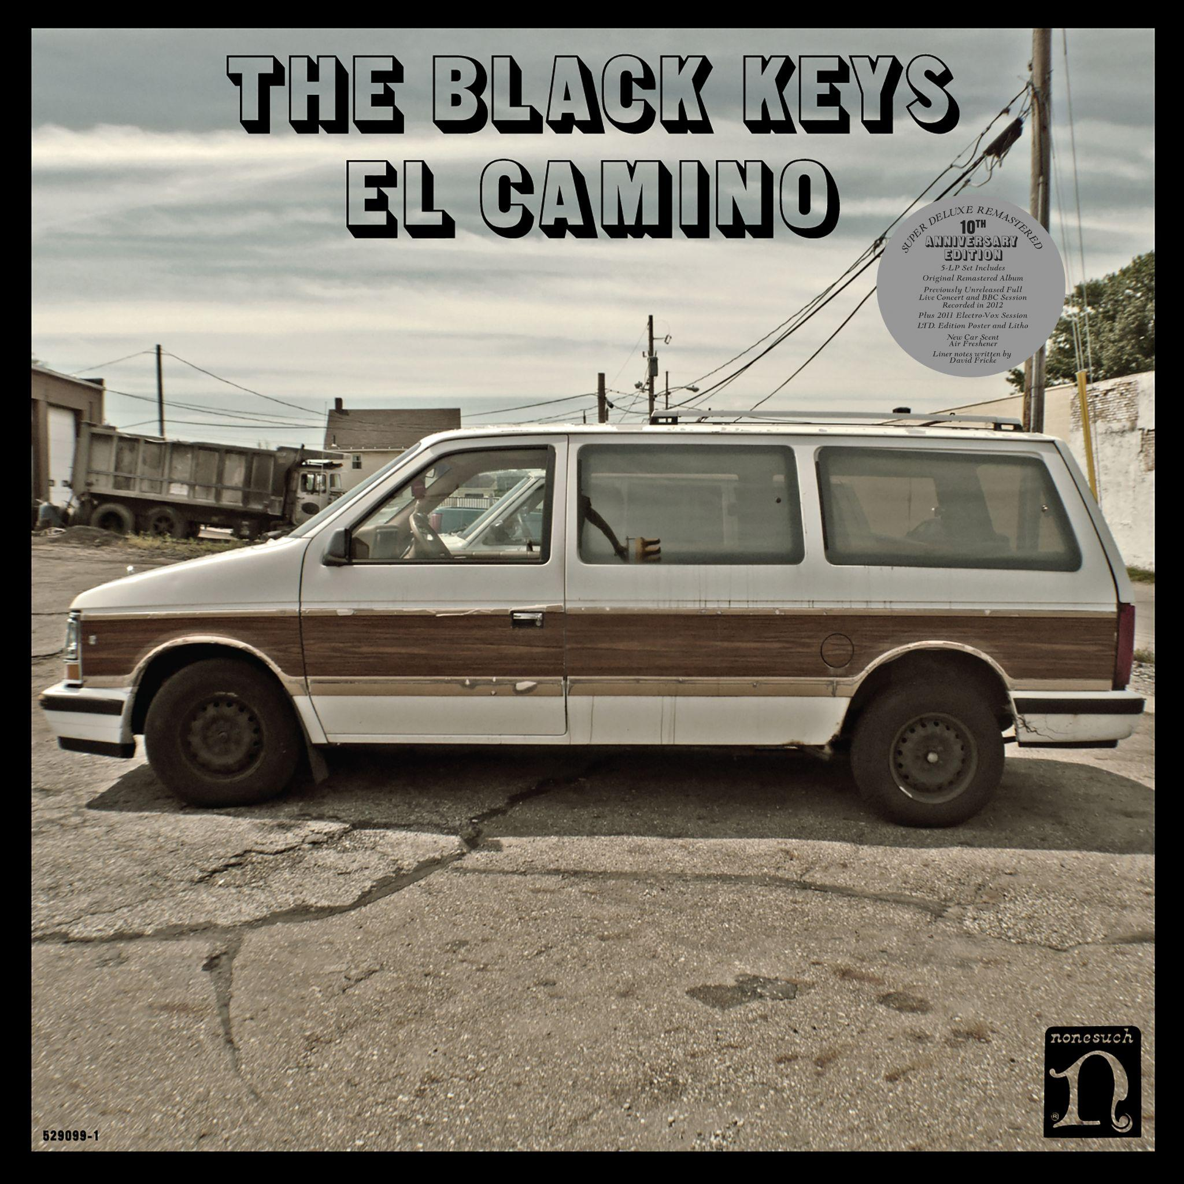

[December 3, 2021 - Los Angeles] The Black Keys’ four-CD Super Deluxe 10th anniversary edition of their landmark seventh studio album, El Camino, is available today on Nonesuch Records. Following the November vinyl and digital release of music from the project, the four-CD version comprises a remastered version of the original album; a previously unreleased recording of a March 6, 2012, concert in Portland, ME.; a BBC Radio 1 Zane Lowe session from 2012; a 2011 Electro-Vox session; an extensive photo book; and a limited-edition lithograph. Mojo says of the anniversary edition, “El Camino feels positively filthy by today’s pop standards, and 10 years on, most classic rock aficionados would take guitar-powered earworms like ‘Lonely Boy’ and ‘Gold On The Ceiling’ in a heartbeat. A textbook document of a fabulously exciting, peaking band,” and Uncut says, “Upbeat and even joyful, the sound of musicians reminding themselves why they wanted to make music in the first place. The songs sound written like they’d be fun to play, a lot, to large crowds. The pick of the bonuses available with this reissue confirms that this was the case.”

El Camino was produced by Danger Mouse and The Black Keys and was recorded in the band’s then-new hometown of Nashville during the spring of 2011. The Black Keys won three awards at the 55th annual Grammys for El Camino—Best Rock Performance, Best Rock Song, and Best Rock Album—among other worldwide accolades.

The week of release, The Black Keys performed El Camino songs on Saturday Night Live (their second appearance that year), the Colbert Report and the Late Show with David Letterman, and later that year, played their first Madison Square Garden show. The Saturday Night Live performances of “Lonely Boy” and “Gold on the Ceiling” are now available to watch.

The album’s first single, “Lonely Boy,” reached #1 on the Alternative and AAA charts; it also entered the top 10 at Rock radio. The second single, “Gold on the Ceiling,” hit #1 on Alternative radio, while the third single, “Little Black Submarines,” reached the top 3.

The El Camino tracks “Lonely Boy” and “Gold on the Ceiling” were certified 2X platinum by the Recording Industry Association of America this week, while “Little Black Submarines” was certified platinum.

In the UK, the album gave the band their first top 10 hit and it has been certified Platinum in the UK, Belgium, France, Ireland, and the Netherlands; Triple Platinum in Australia and New Zealand; Quadruple Platinum in Canada; and Gold in Austria, Denmark, Finland, Italy, Mexico, Norway, Spain, and Switzerland. Of the album’s singles, “Lonely Boy” was certified nine-times Platinum in Canada, Triple Platinum in Australia, Platinum in New Zealand, and Gold in Denmark and the UK. “Gold on the Ceiling” was certified Platinum in Australia and Canada. The Black Keys also were nominated for an MTV European Music Award in 2012.

In other Black Keys news, the duo of singer/guitarist Dan Auerbach and drummer Patrick Carney last week scored a Grammy nomination for Best Contemporary Blues Album for Delta Kream, which was released in May by Nonesuch Records. The project, which features eleven Mississippi hill country blues songs by artists including R.L. Burnside and Junior Kimbrough, was the band’s fifth consecutive top 10 debut on The Billboard 200.

Formed in Akron, Ohio in 2001, The Black Keys have been called “rock royalty” by the Associated Press and “one of the best rock ‘n’ roll bands on the planet” by Uncut. Cutting their teeth playing small clubs, the band have gone on to sell out arena tours and have released nine previous studio albums: their debut The Big Come Up (2002), followed by Thickfreakness (2003) and Rubber Factory (2004), along with their releases on Nonesuch Records, Magic Potion (2006), Attack & Release (2008), Brothers (2010), El Camino (2011), Turn Blue (2014) and “Let’s Rock” (2019), plus a 10th anniversary edition of Brothers (2020).

EL CAMINO (10TH ANNIVERSARY DELUXE EDITION) FORMATS

Super Deluxe:
5-LP Vinyl: Original remastered album, previously unreleased full live concert, 2012 BBC 1 Zane Lowe Session, 2011 Electro-Vox Session, photo book, limited-edition poster and lithograph, “new car scent” air freshener

4-CD: Original remastered album, previously unreleased full live concert, 2012 BBC 1 Zane Lowe Session, 2011 Electro-Vox Session, photo book, lithograph

Digital: Original remastered album, previously unreleased full live concert, 2012 BBC 1 Zane Lowe Session, 2011 Electro-Vox Session

Deluxe:
3-LP vinyl and Snowy White 3-LP Vinyl (fan club only)
Original remastered album, previously unreleased full live concert

EL CAMINO (10TH ANNIVERSARY DELUXE EDITION) Track Listing

Remastered El Camino Album
Lonely Boy
Dead and Gone
Gold on the Ceiling
Little Black Submarines
Money Maker
Run Right Back
Sister
Hell of a Season
Stop Stop
Nova Baby
Mind Eraser

Live in Portland, ME
Howlin’ for You
Next Girl
Run Right Back
Same Old Thing
Dead and Gone
Gold on the Ceiling
Thickfreakness
Girl Is on My Mind
I’ll Be Your Man / Your Touch
Little Black Submarines
Money Maker
Strange Times
Chop and Change
Nova Baby
Ten Cent Pistol
Tighten Up
Lonely Boy
Everlasting Light
She’s Long Gone
I Got Mine

BBC 1 Zane Lowe Session (Super Deluxe Edition only)
Howlin’ for You
Next Girl
Gold on the Ceiling
Thickfreakness
I’ll Be Your Man
Your Touch
Little Black Submarines
Dead and Gone
Tighten Up
Lonely Boy
I Got Mine

Electro Vox Session (Super Deluxe Edition only)
Dead and Gone
Gold on the Ceiling
Howlin’ for You
Lonely Boy
Money Maker
Next Girl
Run Right Back
Sister
Tighten Up


Photo Credit: Michael Carney

https://theblackkeys.com
Twitter
Instagram
Facebook
Youtube

For more information, please contact Grandstand Media:
Kate Jackson - katej@grandstandhq.com
Katie Nelson - katien@grandstandhq.com

For for international enquiries, please contact:
Matthew Rankin, +44 207 938 5552 or matthew.rankin@nonesuch.com

