LAKE STREET DIVE’S VIDEO FOR “HYPOTHETICALS” DEBUTS TODAY
BAND PERFORMS ON THE “LATE SHOW WITH STEPHEN COLBERT” TONIGHT AND
“CBS THIS MORNING: SATURDAY” MARCH 13
NEW ALBUM OBVIOUSLY OUT TOMORROW
ON NONESUCH RECORDS

photo credit: Shervin Lainez
“On Obviously, they’re still oddballs, but in the best way. At a moment when pop strives for lo-fi, solitary-world intimacy, the jazz-pop-whatever band refuses to think small. Fully living up to the water imagery in their name, they’ve made their first truly abashed yacht rock record—with all the hooks, musical interplay, sophistication and sometimes dodgy lyrics of that genre.”

“Call them what you like — alt-country, indie-pop, pop-folk — the hard-to-classify Lake Street Dive offer top-notch songwriting with progressive lyrics and one of the most underrated vocalists in music today.”

March 11, 2021—Lake Street Dive’s video for “Hypotheticals” debuts today; watch/share it HERE. “With all of the uncertainties in the world and in this song, it is a comfort to know definitively that it is VERY FUN to sing and dance with your friends and bandmates,” says bassist Bridget Kearney. “How did it take us 16 years of being a band to make this discovery? It would seem, for lack of a better word.... Obvious. All in good time, though. Now we know. Hoping everyone out there has as much fun singing and dancing to this song as we did while making this video.” “Hypotheticals” is the lead single from the band’s new record Obviously, which is out tomorrow via Nonesuch Records.
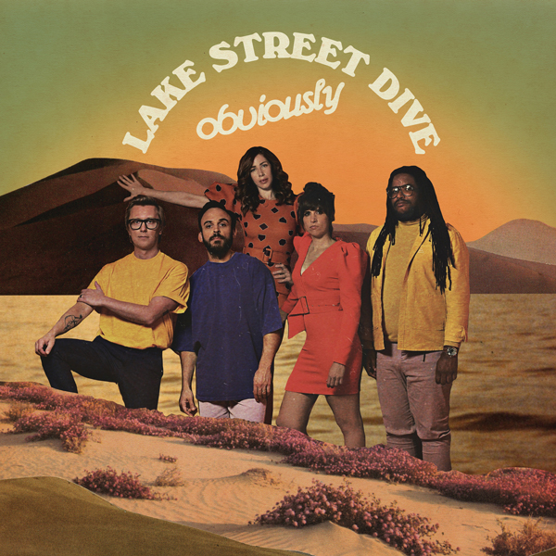
In addition, “Hypotheticals” has been well-received at radio, moving quickly into the Top 20 at AAA and Top 5 on the Non-Comm charts.
In celebration of the release, the band performs on the “Late Show with Stephen Colbert” tonight as well as “CBS This Morning: Saturday Sessions” on March 13.
Most recently, Kearney spoke with NPR’s Weekend Edition about the album track “Being a Woman,” which she wrote. The song speaks to gender inequality and the societal discrimination women face on a daily basis. As Kearney says in her lyrics, “being a woman is a full-time job.” Listen to the full interview HERE.
Obviously is produced by Grammy Award-winning producer, songwriter, and multi-instrumentalist Mike Elizondo, best known as a songwriting collaborator with Dr. Dre, Eminem and 50 Cent. He has also produced records for Fiona Apple, Mary J. Blige, Carrie Underwood and 21 Pilots, among many others. Utilizing Elizondo’s hip-hop record-making expertise, Lake Street Dive’s wide-ranging taste in pop, rock, R&B, and jazz have blended together into a cohesive sound, combining retro influences with a contemporary attitude.
The four original members of Lake Street Dive founded the group in 2004 while attending the New England Conservatory of Music in Boston. The band features Kearney, Rachael Price (lead vocals), Mike “McDuck” Olson (trumpet, guitar), and Mike Calabrese (drums) as well as their newest member Akie Bermiss (keyboards), who began touring with the group in 2017.
Lake Street Dive has released six studio albums, which have an overall consumption in the U.S. of nearly 700,000 units, including more than 350 million streams and 400,000 album sales. Their 2018 self-produced record Free Yourself Up debuted at #4 on Billboard’s Top Album Chart and charted at #8 on the Billboard 200. In addition, the album’s hit single “Good Kisser” peaked at #5 at Americana radio and appeared in the Top 20 at AAA radio, both career peaks for the band. The group has toured internationally, performing at major music festivals including Bonnaroo, New Orleans Jazz, and Newport Folk.
For additional information on the record, see the group’s bio/artist notes HERE.
OBVIOUSLY TRACKLIST
1. Hypotheticals
2. Hush Money
3. Same Old News
4. Being a Woman
5. Making Do
6. Nobody’s Stopping You Now
7. Know That I Know
8. Lackluster Lover
9. Anymore
10. Feels Like the Last Time
11. Sarah
For more information, please contact
Cami Opere, Louis D’Adamio or Carla Sacks at Sacks & Co., 212.741.1000, cami.opere@sacksco.com, louis.dadamio@sacksco.com or carla@sacksco.com.

