For Immediate Release October 28, 2015
THE ARCS VS. THE INVENTORS VOL. I
FEATURING DR. JOHN AND DAVID HIDALGO
TO BE RELEASED ON BLACK FRIDAY
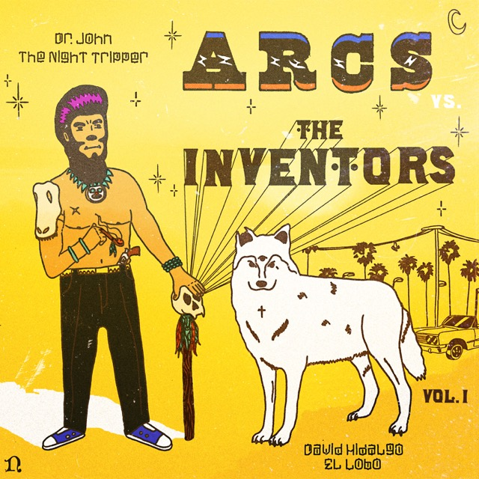
“Yours, Dreamily, takes what Auerbach does at his best, in and out of the Keys—confessional, texturally enriched blues propelled with garage-rock force—and adds a riveting jump in eccentricity.”—Rolling Stone, ★★★★
A new limited-edition 10” six-song recording by The Arcs, entitled The Arcs vs. The Inventors Vol. I, featuring Dr. John and David Hidalgo, will be released on Nonesuch Records November 27, 2015, as part of Record Store Day’s Black Friday event; a digital version of The Arcs vs. The Inventors Vol. I will be available December 11.
The disc is the first in a series of collaborative “Inventors” recordings to be released by The Arcs. The band’s Dan Auerbach says of the project, “Sometimes the best way to see into the future is to study the past. In this series we do both, collaborating with folks who have been in the game a long time but instead of rehashing old material, we collaborate on new works, explore new ideas and introduce each other to a different generational perspective. We'll continue in this series to track down our heroes and bug them until they agree to make some noise with us. Hopefully we learn a thing or two. Yours, Dreamily,”
The Black Friday release follows The Arcs’ debut album, Yours, Dreamily, which was recently released to critical acclaim (purchase now from your favorite record store, thearcs.com, and nonesuch.com). In support of the records, the band—which features Auerbach, Leon Michels, Richard Swift, Homer Steinweiss, and Nick Movshon along with special guests Mariachi Flor de Toloache—will embark upon their first tour this fall, with European shows in November and North American dates in December at Chicago’s The Vic, Akron’s Civic Theatre, New York’s Terminal 5, and Nashville’s Ryman Auditorium, among others. All tickets are now on-sale (see below for complete details).
THE ARCS VS. THE INVENTORS VOL. 1 TRACK LISTING:
SIDE A
1. Skull Session (feat. Dr. John on piano)
2. Young
3. Virginia Slim (feat. Dr. John on organ, David Hidalgo on guitar)
SIDE B
1. Blessed & Burned (feat. Dr. John on piano, David Hidalgo on organ)
2. Janitor (feat. Dr. John on piano)
3. Between the Devil and the Deep Blue Sea (feat. Dr. John on organ)
THE ARCS EUROPEAN TOUR DATES
November 5 Cologne, Germany Kantine
November 6 Berlin, Germany Postbahnhof
November 8 Zurich, Switzerland X-TRA
November 9 Brussels, Belgium Ancienne Belgique
November 11 London, UK The Forum
November 12 Amsterdam, Holland Melkweg Max
November 13 Paris, France Le Trianon
November 16 Milan, Italy Alcatraz
THE ARCS U.S. TOUR DATES
December 1 Minneapolis, MN First Ave
December 2 Chicago, IL The Vic
December 3 Chicago, IL The Vic
December 4 Columbus, OH LC Pavilion
December 6 Detroit, MI Fillmore Detroit
December 8 Akron, OH Akron Civic Theatre
December 9 New York, NY Terminal 5
December 10 Toronto, ON Massey Hall
December 12 Boston, MA Orpheum Theatre
December 14 Washington, DC 9:30 Club
December 16 Philadelphia, PA The Fillmore
December 19 Charlotte, NC Amos’ Southend
December 20 Nashville, TN Ryman Auditorium
www.thearcs.com
For more information, please contact Mary Moyer 212.741.1000,
Carla Sacks 212.741.1000 or Asha Goodman 615.320.7753 at Sacks & Co., mary@sacksco.com, carla@sacksco.com or asha.goodman@sacksco.com.

