ROBERT PLANT RETURNS WITH CARRY FIRE,
TO BE RELEASED ON OCTOBER 13

PRE-ORDERS AVAILABLE TODAY

FIRST TRACK, "THE MAY QUEEN," AVAILABLE NOW

2018 WORLD TOUR TO BE UNVEILED SOON

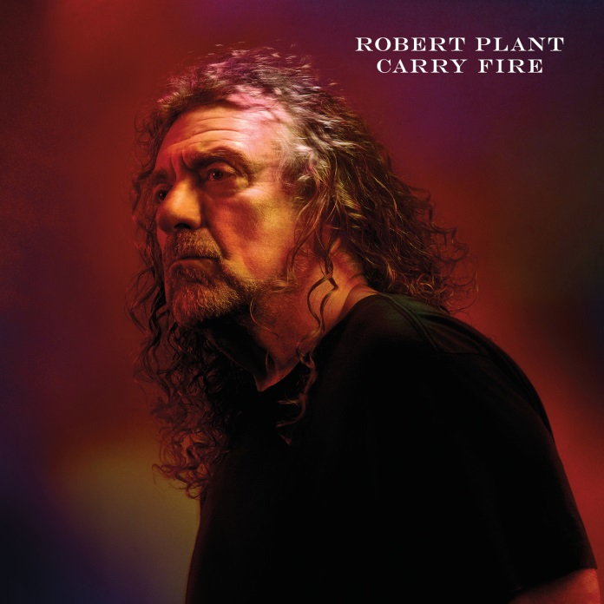

Robert Plant's new album, Carry Fire, will be released by Nonesuch/Warner Bros. Records on Friday, October 13, 2017. Carry Fire is available now for pre-order at all digital music retailers and via nonesuch.com and robertplant.com with an instant download of the album's first track, "The May Queen." Pre-orders via nonesuch.com and robertplant.com also include an exclusive limited-edition print featuring a beautiful image from the album art.

Carry Fire, his eleventh solo album and first full-length release since 2014's acclaimed lullaby and...The Ceaseless Roar, was produced by Plant in the west of England and Wales, at Top Cat studio in Box, Wiltshire with additional recordings at Real World and Rockfield studios. As with lullaby, Plant is accompanied by The Sensational Space Shifters: Justin Adams on guitar, acoustic guitar, oud, E-bow quartet, percussion, snare drum, tambourine; John Baggott on keyboards, moog, loops, percussion, drums, brass arrangement, t'bal, snare drum, slide guitar, piano, electric piano, bendir; Billy Fuller on bass, keyboards, and drum programming; Dave Smith on bendir, tambourine, djembe, drum kit; and Liam "Skin" Tyson on dobro, guitar, acoustic guitar, pedal steel, and twelve-string.

Plant and the Space Shifters are also joined on Carry Fire by a number of special guests. Chrissie Hynde joins Plant on the duet "Bluebirds Over The Mountain" (written by rockabilly legend Ersel Hickey and later recorded by both Richie Valens and The Beach Boys). Albanian cellist Redi Hasa performs on three tracks, as does the celebrated Seth Lakeman on viola and fiddle.

Plant and the Space Shifters (which now includes Lakeman) will celebrate Carry Fire's release by beginning a world tour in November 2017 starting in UK & Ireland and touring all corners of globe from thereon. Dates will be announced soon; for updates, please visit www.robertplant.com.

Plant and the band spent two years on the road together supporting lullaby and...The Ceaseless Roar, their unique sound and vision ultimately evolving into something even more creative and powerful.

Plant, who lived in Texas for a time before returning to his native England three years ago, together with his friends, present the songs Carry Fire, melding unusual rhythms with naturalism and smoldering power.

"It's about intention, I respect and relish my past works but each time I feel the lure and incentive to create new work. I must mix old with new. Consequently the whole impetus of the band has moved on its axis somewhat, the new sound and different space giving way to exciting and dramatic landscapes of mood, melody and instrumentation".

lullaby and...The Ceaseless Roar (Nonesuch/Warner Bros. Records) made top ten debuts around the globe upon its release, from the US's SoundScan/Billboard 200 to album charts in Belgium, Canada, Finland, Hungary, Italy, New Zealand, Norway, Poland, Sweden, Switzerland, and the United Kingdom.

Along with its international commercial appeal, lullaby and...The Ceaseless Roar drew rave reviews from such high profile media outlets as NPR Music, which named it to their "50 Favorite Albums of 2014," noting, "(Plant) is still a majestic rock presence, at peace with the legacy of his hard-rock-defining band Led Zeppelin, while remaining relentlessly creative in his solo work... (The album) lovingly layers elements in ways that mirror memory, creating new constructs from floating shards of the musical past." "Robert Plant knows where rock's past begins and he's pulling it into the future," wrote the Wall Street Journal while the New York Times praised the singer's "otherworldly voice: sustained, androgynous, balanced between serenity and ache."

Britain's Guardian declared lullaby and...The Ceaseless Roar to be "fantastic: gritty, dark, and satisfying" while also making special mention of Plant's "hugely impressive backing band, the Sensational Space Shifters... There's something almost alchemical about their ability to draw together incongruent musical influences into something coherent and exciting.” Pitchfork called lullaby “the most bravely confessional writing of his career.”

ROBERT PLANT
Carry Fire

(Nonesuch/Warner. Bros)

Release Date: Friday, October 13, 2017

- The May Queen
- New World...
- Season's Song
- Dance With You Tonight
- Carving Up The World Again... a wall and not a fence
- A Way With Words
- Carry Fire
- Bones Of Saints
- Keep It Hid
- Bluebirds Over The Mountain
- Heaven Sent

PRODUCED BY ROBERT PLANT

"enwog yth wnair, gair gyrddbwyll armes, telynores twyll"

FOR MORE INFORMATION, PLEASE VISIT ROBERTPLANT.COM AND NONESUCH.COM

Press contacts:

Ken Weinstein weinstein@bighassle.com

Melissa Cusick Melissa.Cusick@Nonesuch.com

