For Immediate Release October 17, 2017
DAN AUERBACH ANNOUNCES 7” EASY EYE SOUND SAMPLER, GOOD SOUND COMES BACK AROUND VOL. 1
INCLUDES NEW MUSIC FROM AUERBACH, ROBERT FINLEY, & SONNY SMITH
WAITING ON A SONG OUT NOW VIA EASY EYE SOUND
TOUR DATES WITH JOHN PRINE CONFIRMED

“It’s a ‘Nashville Sound’ the town could use more of.”
– Rolling Stone

“Auerbach is a craftsman of rare skill and few equals.”
– Mojo

“…the end result is ultimately a testament to the great paradox of songwriting: it takes a lot of heavy lifting to make something that sounds so effortless.”
-Pitchfork

This morning, eight-time GRAMMY–winner, Dan Auerbach, announces a 7” Easy Eye Sound sampler, Good Sound Comes Back Around Vol. 1, which will be released on Friday, November 24th, as part of Record Store Day’s Black Friday initiative. The new 7” is a preview of upcoming releases on Auerbach’s label and features “Cellophane Angel,” an exclusive and unreleased track Auerbach recorded with the Preservation Hall Band, on Side A, and Robert Finley's "Medicine Woman"— the first single on Goin’ Platinum! due December 8th— and Sonny Smith's "Pictures of You" on Side B. Sonny Smith will be releasing a full-length album on Auerbach’s label soon. The 7” will be available at participating record stores, and more information can be found here.

Auerbach’s new solo album, Waiting On A Song, which NPR Music calls “a batch of sparkling pop songs that's sweet, breezy, and primed for summer,” is out now on Easy Eye Sound, and you can listen to it here. The album is Auerbach’s follow-up to 2009’s Keep It Hid and is his love letter to Nashville. As such, he recruited some of Nashville’s most respected players to write and record his latest, including John Prine, Duane Eddy, Jerry Douglas, Russ Pahl, Pat McLaughlin as well as Bobby Wood and Gene Chrisman of the Memphis Boys. Auerbach said about working with his musical heroes: “Living in Nashville has definitely changed the way I think about music and the way that I record it. I didn’t have all of these resources before. I am working with some of the greatest musicians that ever lived.”

Auerbach, along with Robert Finley, will appear on “A Prairie Home Companion” with host Chris Thile, on October 28th. With nearly 3.2 million fans from around the world tuning in to enjoy the show each week, “A Prairie Home Companion” is the only live music and variety show aired nationwide today.
Recently, Dan Auerbach debuted the music video for “Stand By My Girl” via Stereogum. Auerbach also appeared on CBS This Morning: Saturday for an in-depth interview with host Anthony Mason about his new album, Waiting On A Song, from which he played three songs, “Shine On Me,” “Waiting On A Song,” and “Never In My Wildest Dreams.” Watch the interview and performance here. Additionally, Auerbach premiered his music video for “Waiting on A Song” via Rolling Stone and appeared on The Late Show With Stephen Colbert recently to perform the songs “Shine On Me” and “King Of A One Horse Town”. NPR Music premiered the video for Waiting On A Song’s first single, “Shine on Me”. Auerbach also shared the music video for “King of a One Horse Town” via Pitchfork.
Dan Auerbach will open for John Prine, with whom he wrote the title track off Waiting On A Song, in November in Washington D.C. and Richmond. Additionally, Auerbach will perform at The Growlers Six festival in San Pedro, CA on Saturday, October 28th. Tickets for these performances on sale now and are available here.
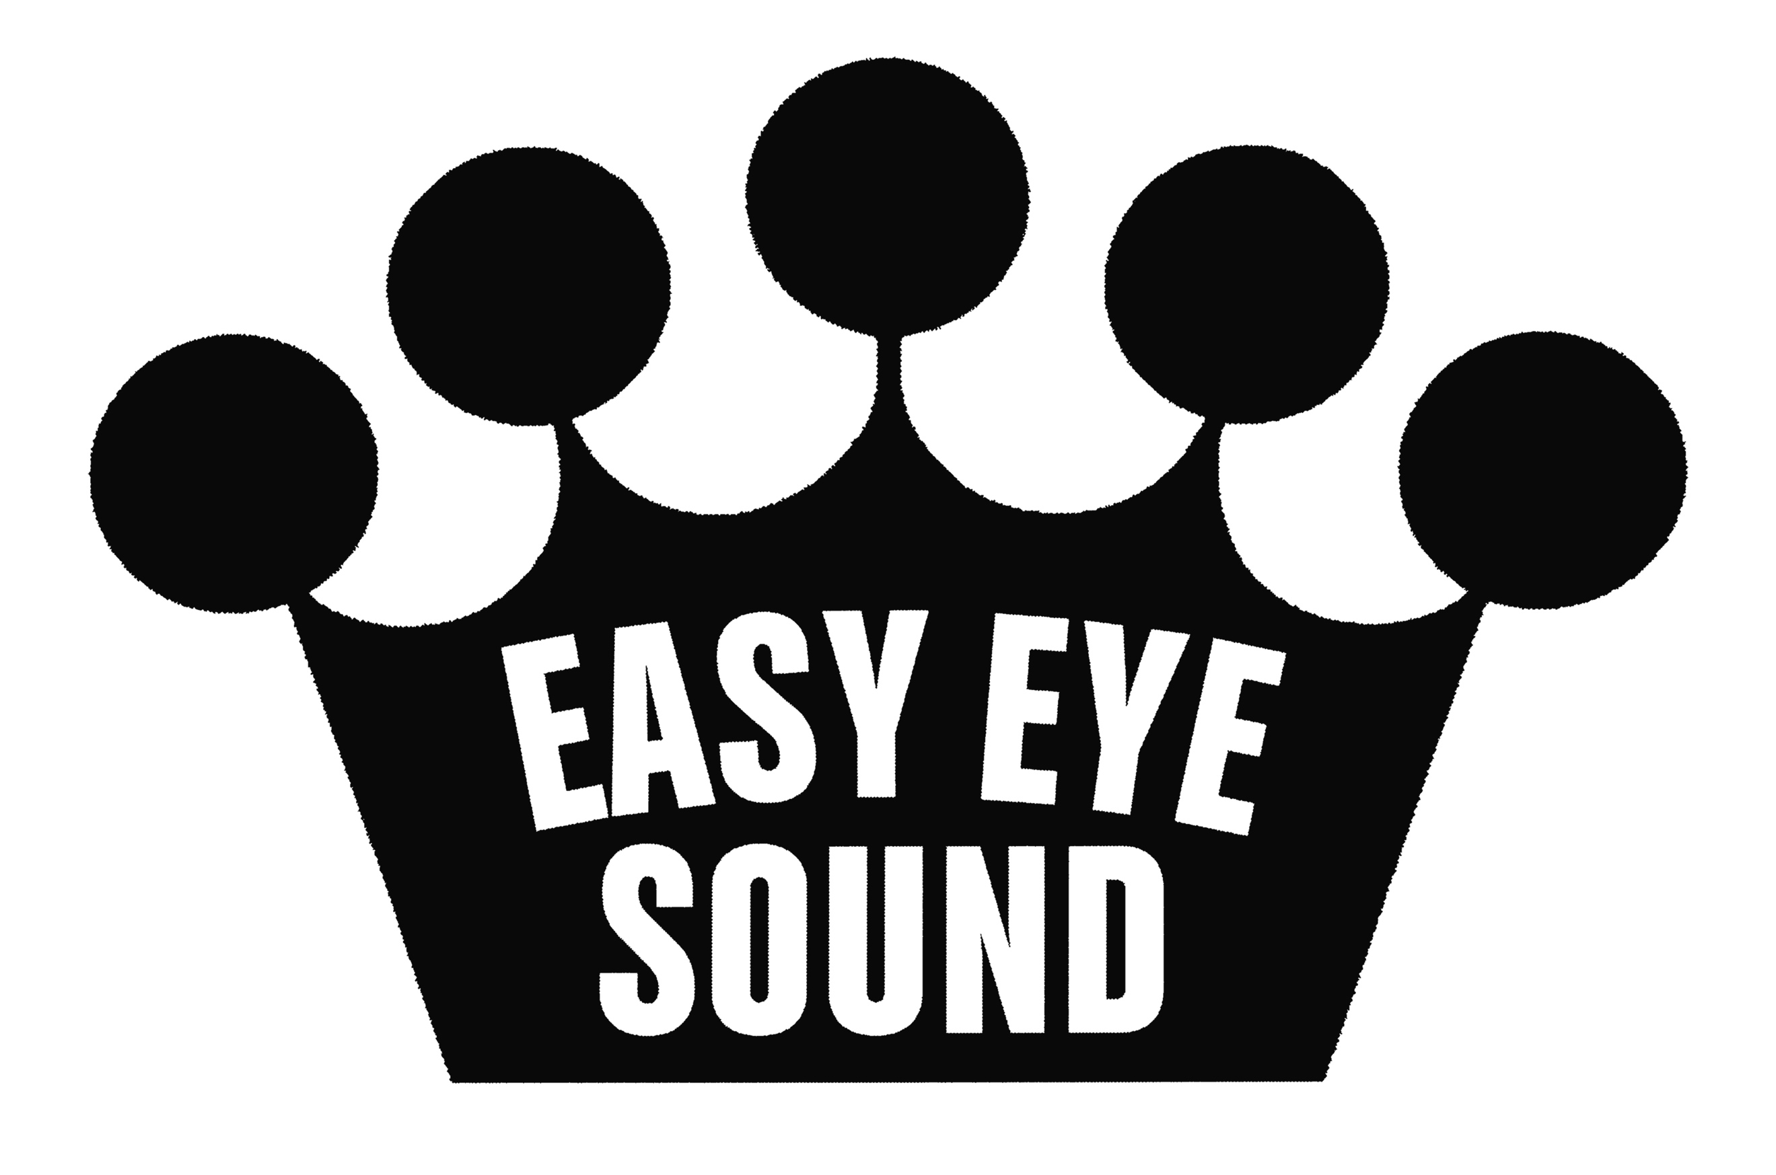
Waiting On A Song is the debut release, and marks the launch of Easy Eye Sound, Dan Auerbach’s new record label which will feature releases from other artists and is distributed by Auerbach's longtime label Nonesuch Records. The next release on Easy Eye Sound will be of legendary bluesman Robert Finley’s new album this fall. Easy Eye Sound is built equally around Auerbach’s Easy Eye Studio in Nashville, where The Black Keys recorded their last two albums, as well as the collection of famous session musicians that have come to call the studio home. Auerbach says, “Sometimes I feel I created my own Field of Dreams. I built the studio because I knew something was going to happen. I built it to accommodate live musicians playing, and then all of a sudden the best musicians in Nashville show up, and it’s happening.”
Dan Auerbach- Waiting On A Song Track List
1. Waiting On A Song
2. Malibu Man
3. Livin' In Sin
4. Shine On Me
5. King Of A One Horse Town
6. Never In My Wildest Dreams
7. Cherrybomb
8. Stand By My Girl
9. Undertow
10. Show Me
Dan Auerbach Tour Dates w/ John Prine
October 28 /// San Pedro, CA /// Growlers Fest
November 10 /// Washington DC /// DAR Constitution Hall
November 11 /// Richmond VA /// Altria Theater
http://easyeyesound.com/
https://www.facebook.com/danauerbachmusic/
https://www.facebook.com/easyeyesound
https://twitter.com/danauerbach
https://twitter.com/easyeyesound

