Lianne La Havas Releases Five-Song EP Today, Live at the Roundhouse,
Featuring Performances from Last Summer’s London Concert

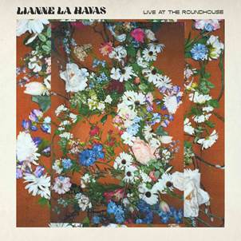

“Graceful melodies, supple guitar syncopations, sophisticated harmonies and a voice that can sparkle with anticipation or cry out in pain capture all the hope and heartache of her narrative.”—New York Times

English singer/songwriter/guitarist Lianne La Havas’ self-titled album, released to critical acclaim in July, made Best of 2020 lists from media outlets including the New York Times, NPR, Pitchfork, Stereogum, Noisey, and many others. Today—December 18, 2020—she releases Live at the Roundhouse, an EP of five tracks she performed during an intimate live-streamed concert, also in July, at London’s Roundhouse.

The EP, intended as a balm at a time when live music is all but impossible due to the pandemic, includes the Lianne La Havas album tracks “Seven Times,” “Paper Thin,” “Courage,” and “Bittersweet,” as well as “Midnight” from her previous album, Blood. La Havas’ Roundhouse performance of “Bittersweet” was featured on the Late Show with Stephen Colbert’s #PlayAtHome series, which can be seen here. Vocalist Frida Touray joined La Havas for the song; she also sings on “Midnight.”

The ten songs on Lianne La Havas—nine originals plus a cover of Radiohead’s “Weird Fishes”—span the arc of a love affair, one that brought growth and newfound confidence. “This is my first completely self-produced album with my own band. I got my own way with everything—all the decisions that you hear on this album were mine,” she says. “I’m a woman now, so I’m less shy and timid about saying certain things. And there’s no right or wrong when it’s your record, so I was very much embracing that fact, as well.

“What plays a big role in the album is the idea of the life cycle of plants and nature—equating this journey with a seasonal thing that blooms, thrives, goes away, and comes back even stronger,” La Havas says. “A flower has to dry up and die in order to be reborn. You have to get to the rock bottom to rebuild yourself.”

For more information, visit publicity.nonesuch.com, or contact:
Melissa Cusick, Nonesuch Records, melissa.cusick@nonesuch.com or
Aishah White, Warner Records, aishah.white@warnerrecords.com.

# # # #

