Conor Oberst’s Ruminations (Expanded Edition) out Today via Nonesuch

New edition, previously released for Record Store Day, features five bonus tracks

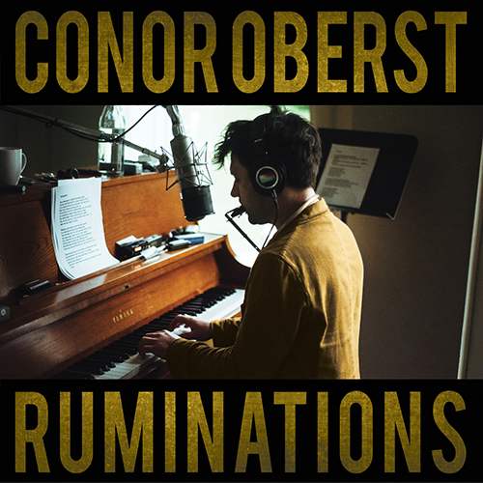

“Ruminations feels … like a direct line into the spirit of Right Now … Oberst reckons with having the fabric of his life ripped apart by a disease of the flesh he couldn’t control or understand. Perhaps that sounds familiar?

“[He] paints a startling picture of how surreal life becomes when backlit by illness … these songs are heartrendingly beautiful, filled with the beauty of day-drunkenness and Proustian flights into memory and waking up in the afternoon and realizing that, however imperfect the day is, it’s a day.” —GQ (2020)

Conor Oberst’s Ruminations (Expanded Edition) is available on all formats today—July, 23, 2021—via Nonesuch Records. The expanded edition of Oberst’s critically acclaimed 2016 solo album, first available in limited release on vinyl for Record Store Day's RSD Drops last month, features five bonus tracks, four previously unreleased, as well as an etching on side D of the double LP. The five bonus tracks were recorded during the Ruminations sessions; while full band versions of them were released on the 2017 companion album Salutations, these solo acoustic recordings are now included for the first time on Ruminations.

Ruminations was recorded in the winter of 2016, when Oberst found himself hibernating in his hometown of Omaha after living in New York City for more than a decade. He emerged with the unexpectedly raw, unadorned album, which NPR called one of his “most personal records … a collection of brave, dark songs … unmistakably moving and contain[ing] some of Oberst's best lyrics and imagery.” The UK’s Sunday Times further said it was his “rawest album yet …. Political and very, very personal,” calling Oberst “one of the best songwriters around.”

“I wasn't expecting to write a record,” said Oberst in 2016. “I honestly wasn’t expecting to do much of anything. Winter in Omaha can have a paralyzing effect on a person but in this case it worked in my favor. I was just staying up late every night playing piano and watching the snow pile up outside the window. Next thing I knew I had burned through all the firewood in the garage and had more than enough songs for a record. I recorded them quick to get them down but then it just felt right to leave them alone.”

In the Nebraska studio he built with his Bright Eyes bandmate and longtime friend Mike Mogis, Oberst recorded all the songs in the span of forty-eight hours. The results are almost sketch-like in their sparseness, and they ultimately became the songs that comprise Ruminations. These tracks do not have the multi-layered instrumentation of the most recent Bright Eyes and solo albums: This is Oberst alone with his guitar, piano, and harmonica; the songs connect with some of the rough magic and anxious poetry that first brought him to the attention of the world.

Ruminations (Expanded Edition) Track List:

- Tachycardia
- Barbary Coast (Later)
- Gossamer Thin
- Counting Sheep
- Mamah Borthwick (A Sketch)
- The Rain Follows the Plow
- A Little Uncanny
- Next of Kin
- You All Loved Him Once
- Till St. Dymphna Kicks Us Out
- Overdue *
- Too Late to Fixate *
- Afterthought **
- Empty Hotel by the Sea *
- Napalm *

* previously unreleased
** released as 7” and digitally in late 2016 (with full band version of “Tachycardia” on reverse)

For more information, please visit publicity.nonesuch.com or contact:
Melissa Cusick, melissa.cusick@nonesuch.com

# # # #

