Nonesuch Releases for the first time 1990 Live Recording of Emmylou Harris and the Nash Ramblers at
Tennessee Performing Arts Center: Ramble in Music City: The Lost Concert on September 3

Album from legendary, Grammy-winning group was recorded during band’s
hometown debut and sat unreleased in vault for three decades

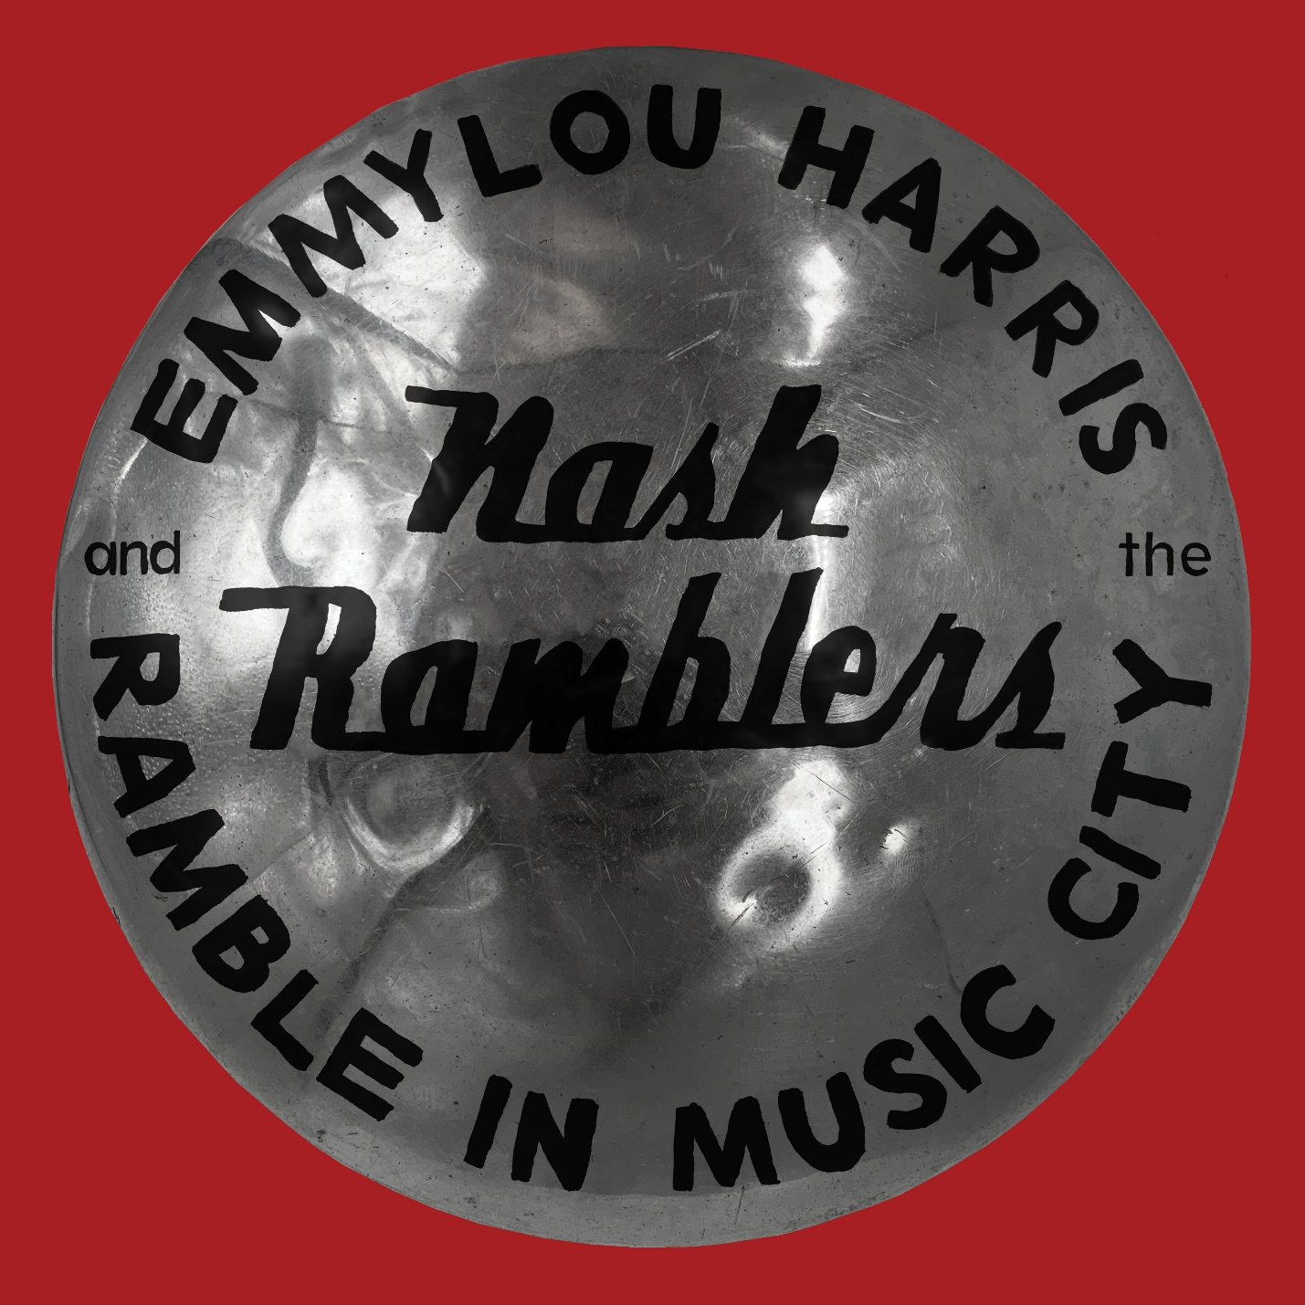

“Her string band exhilarates, especially Sam Bush on mandolin, while she sounds absolutely inspired.”
—Boston Globe

Nonesuch releases Ramble in Music City: The Lost Concert for the first time on September 3, 2021. In 1990, after fifteen years of touring with the beloved Hot Band, Emmylou Harris formed the Nash Ramblers, a new acoustic all-star group, featuring Sam Bush (fiddle, mandolin, vocals), Roy Huskey Jr. (bass), Larry Atamanuik (drums), Al Perkins (dobro, banjo, vocals), and Jon Randall Stewart (acoustic guitar, mandolin, vocals). The band played on the road for several months before making their Nashville debut at the Tennessee Performing Arts Center (TPAC) on September 28, 1990. That concert was recorded and shelved, while another live run at the Ryman Auditorium the following spring was released as Emmylou Harris and the Nash Ramblers At the Ryman to great acclaim, winning a Grammy and spurring public interest in saving the beloved music hall. Now, more than thirty years later, Rhino’s James Austin has unearthed the 1990 TPAC recording for its first release on Nonesuch. The TPAC set features entirely different songs from the Ryman album and includes music by A.P. Carter, Rodney Crowell, Ruth Franks, the Louvin Brothers, Doc Pomus and Mort Shuman, Paul Simon, and Townes Van Zandt, among others, as well as her own compositions (track list below).

Album pre-orders from the Nonesuch Store, which are available now, include an exclusive, limited-edition print autographed by Harris while they last. A video of Harris and the Nash Ramblers performing the album track “Roses in the Snow” on a 1993 Austin City Limits broadcast may be seen here.

Harris says of Ramble in Music City: “When James Austin, in my humble opinion, the world’s best and certainly most devoted music archeologist, unearthed the tapes of this ‘lost’ concert, I was taken aback by their very existence, like finding some cherished photograph misplaced so long ago the captured moment had been forgotten. Then the memories came flooding in, of the Nash Ramblers, hot off the road from our first tour, ready to rock and bringing their usual A-game to the hometown turf.

“It only took one listen to realize not a single note was out of place or in need of repair, a truly extraordinary performance by these gifted musicians. What a joy it was to share the stage with them.”

A thirteen-time Grammy winner and Billboard Century Award recipient, Emmylou Harris' contribution as a singer and songwriter spans six decades. She has recorded more than thirty albums and has also contributed to countless fellow artists' recordings. In recognition of her remarkable career, Harris was inducted into the Country Music Hall of Fame in 2008. Her most recent new release, a collaboration with Rodney Crowell, The Traveling Kind, followed the longtime friends' first duet album, Old Yellow Moon, which won a Best Americana Album Grammy Awards as well as two Americana Music Association Awards, for Album of the Year and Duo/Group of the Year.
Emmylou Harris and the Nash Ramblers
Ramble in Music City: The Lost Concert (1990)

1. Roses in the Snow
Ruth Franks
2. Even Cowgirls Get the Blues
Rodney Crowell
3. Beneath Still Waters
Dallas Frazier
4. If I Could Only Win Your Love
Charlie & Ira Louvin
5. Amarillo
Emmylou Harris/Rodney Crowell
6. The Other Side of Life
Alan O’Bryant
7. If I Needed You
Townes Van Zandt
8. Two More Bottles of Wine
Delbert McClinton
9. Mystery Train
Herman Parker
10. My Songbird
Jesse Winchester
11. Wayfaring Stranger
John Wyeth
12. Green Pastures
Traditional
13. Blue Kentucky Girl
Johnny Mullins
14. Hello Stranger
A.P. Carter
15. Remington Ride
Herb Remington
16. One of These Days
Earl Montgomery
17. The Boxer
Paul Simon
18. Born to Run
Paul Kennerley
19. The Price I Pay
Bill Parker Wildes/Christopher Hillman
20. Sweet Dreams
Don Gibson
21. Save the Last Dance for Me
Doc Pomus/Mort Shuman
22. Leaving Louisiana in the Broad Daylight
Rodney Crowell/Donovan Cowart
23. Boulder to Birmingham
Emmylou Harris/Bill Danoff

For more information, visit publicity.nonesuch.com or contact: melissa.cusick@nonesuch.com.

# # # #

