BEN LAMAR GAY RELEASES
﻿OPEN ARMS TO OPEN US

OUT TODAY VIA
INTERNATIONAL ANTHEM / NONESUCH

Album Release Show Confirmed for January 18, 2022 at
Public Records as part of NYC Winter Jazzfest



Ben LaMar Gay by Chelsea Ross (download)

Open Arms to Open Us
LISTEN: https://smarturl.it/openarmstoopenus

“an improviser from Chicago’s South Side who has achieved a sort of cult-hero stature"
WBGO

“a postmodern folklorist”
New York Times

“genre-defying artist”
BrooklynVegan

“Chicago composer and cornetist Ben LaMar Gay makes music that transcends physical borders and conceptual boundaries.”
The FADER

“ [Open Arms to Open Us] is Gay’s most cohesive artifact to date”
Chicago Reader

"Open Arms to Open Us leaps across all sorts of portals, dipping into the dawn of jazz right on through its vibrant present moment, with glints of woozy hip-hop, Prince-ly funk, wordless ululations, Tropicália and gospel yips thrown in for good measure." -Washington Post

Open Arms to Open Us
prologue by Ben LaMar Gay

Growing up, spending summers in Alabama, one of my favorite chores was feeding the pigs that were on my great Aunt Lola’s land. Sometimes while on the path to the feeding grounds, Aunt Lola and I would stand still and listen together. We would immediately become aware of winds approaching through wavering pines, quail songs and the chatter of distant cousins just up the road.

Once she told me that during a certain time of day she can hear her father hammering away in the field near the old house where she grew up. Even though her father was long deceased, she could clearly hear the rhythm and feel his presence.

This was my first conscious experience with thermodynamics and its first law that states energy can neither be created nor destroyed, just transferred. The moment, environment, memory, and open listening of my great Aunt allowed a sound from the past to resonate in the present for my 7 year old ears.

The awareness of a moment, environment, memory, and open listening are also the makings of a great improviser. With the idea of freedom being a “dangling carrot” for most, my now mature and “forever learning” ears have realized that improvisation is the one freedom that we all have access to. I remember the clarity of my great grandfather’s hammer. The silence in between each strike was what drew Aunt Lola and me in, closer. From that moment on, I’ve carried my curiosity of the world inside my front pocket at all times.

This experience is at the root of this bundle of sound, Open Arms to Open Us.

I started visualizing this music during the Spring of 2020, in the global thickness of being faced with mortality in a different way. If not mortality, faced once again with the crumbling of societal facades. Things aren’t okay. Things have never been okay, at least in this brief period of the planet where man sells and kills for ownership of the earth.

Along with brief feelings of dismay and desires of survival, I began to think about future ears and the continuation of magic with or without me. I often found myself wondering: What can I leave behind for the young people in my life? These young messengers, these young creatives, these young listeners who know me or have heard about me from their parents via stories, pictures, or sounds from the house/car stereo.

All I could think about was my nieces and nephews… blood and beyond. If they ever look back and wonder what their uncle/their messenger was thinking about during this interesting time or rotation of the earth, I want them to know that I was thinking about them, the future of this circle, the future of this curiosity, the future of this exploration. I spent my time believing in them.

Open Arms to Open Us deals with rhythm as an inheritance of information – sort of like DNA or RNA. Coping with the present-day bombardment of data and recycled ideologies from sources essentially fed by the creed “Destroy Them. Own the Earth” often leaves me with only one thing to look forward to: Rhythm. More than anything, I’d like my babies to always trust in rhythm. It’s the one trueness that travels great distances and constantly survives the crumbling of facades.

While living inside the interesting rotations of the earth, we are constantly dealing with man-made loops that often leave us with questions such as: Who constructed this loop? Who does this loop benefit? Who does this loop exploit? How can I survive in this loop? How can I destroy this loop? Maybe if we reach beyond the generic names and virtuosic execution of rhythms to better understand the dialogue between rhythms and our bodies we could release the message that has

been carried for centuries inside of them. These messages sent from the ancient and future loved ones could possibly be the key to revamp, upgrade, tweak, quell, and pacify particular loops.

Open Arms to Open Us is full of rhythm or information that will assist my young folk in dealing with the repetition of things that aim to harm them or stunt their holistic progression. The title is a suggestion of a body movement that is used in many spiritual practices and is also a gesture that represents a type of understanding that leads to touch or a hug. The music is for dancing, reflecting, celebrating, bellowing, bawling, stimulation, focus and deciphering messages from loved ones here and beyond. It was the space in between the sound of my great grandfather’s hammer that made me understand that, no matter what, We Gon Win.

BLG - August, 2021

NYC Winter Jazzfest & International Anthem present
BEN LAMAR GAY
Open Arms to Open Us Album Release Performance
with opening set by JAIMIE BRANCH (solo)
Tuesday January 18, 2022
at PUBLIC RECORDS
233 Butler St, Brooklyn NY
Ticket Buy-Link Here
﻿

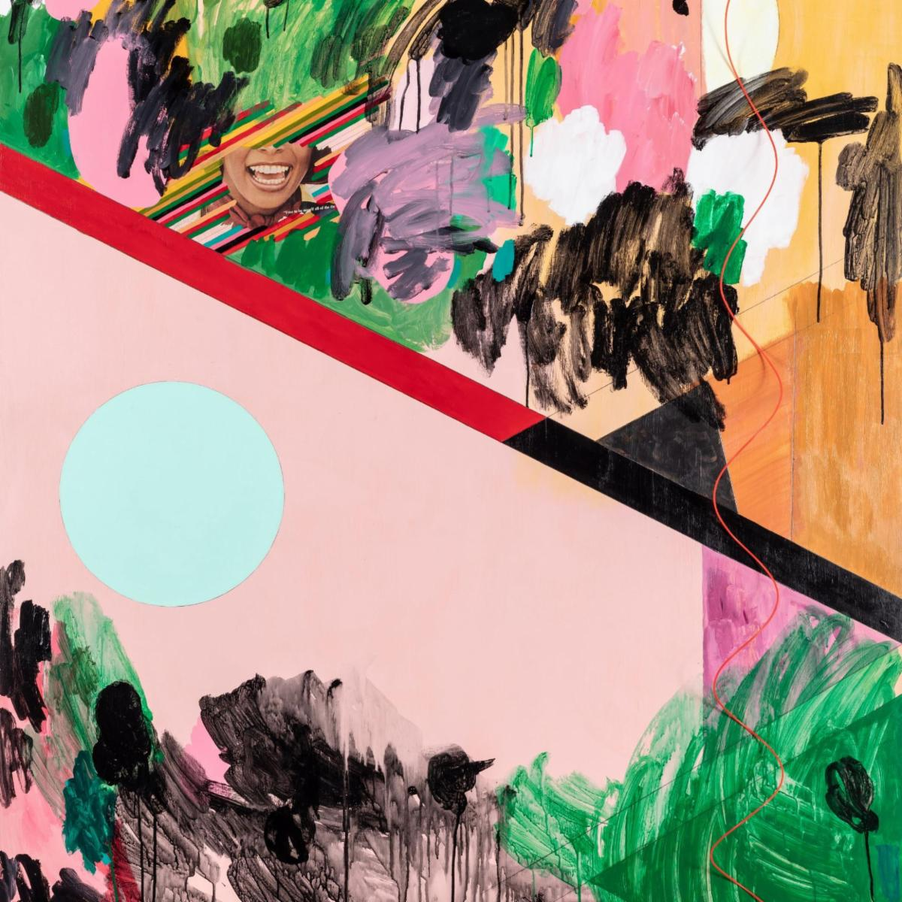

(download)

Ben LaMar Gay
Open Arms to Open Us
November 19, 2021
International Anthem / Nonesuch

1. Sometimes I Forget How Summer Looks On You. (ft. Ohmme)
2. Hood Rich Happy
3. Band Melodically Bang
4. Aunt Lola and The Quail
5. Mestre Candeia’s Denim Hat
6. Oh Great Be The Lake
7. I Be Loving Me Some of You
8. Nyuzura (ft. Dorothée Munyaneza)
9. Slightly Before The Dawn
10. Lean Back. Try lgbo. (ft. Onye Ozuzu)
11. Dress Me In New Love
12. Touch. Don’t Scroll (ft. Ayanna Woods)
13. I Once Carried a Blossom (ft. A.Martinez)
14. In Tongues And In Droves (ft. Tomeka Reid)
15. S’Phisticated Lady (ft. Gira Dahnee & Angel Bat Dawid)
16. We Gon Win

(Download hi-res assets HERE)

