THE BLACK KEYS’ NEW ALBUM, DROPOUT BOOGIE, OUT TODAY VIA NONESUCH

STREAM THE ALBUM HERE

IHEART PERFORMANCE TO BE LIVE-STREAMED TONIGHT

BAND PERFORMED “WILD CHILD” & “IT AIN’T OVER” ON JIMMY KIMMEL LIVE! LAST NIGHT

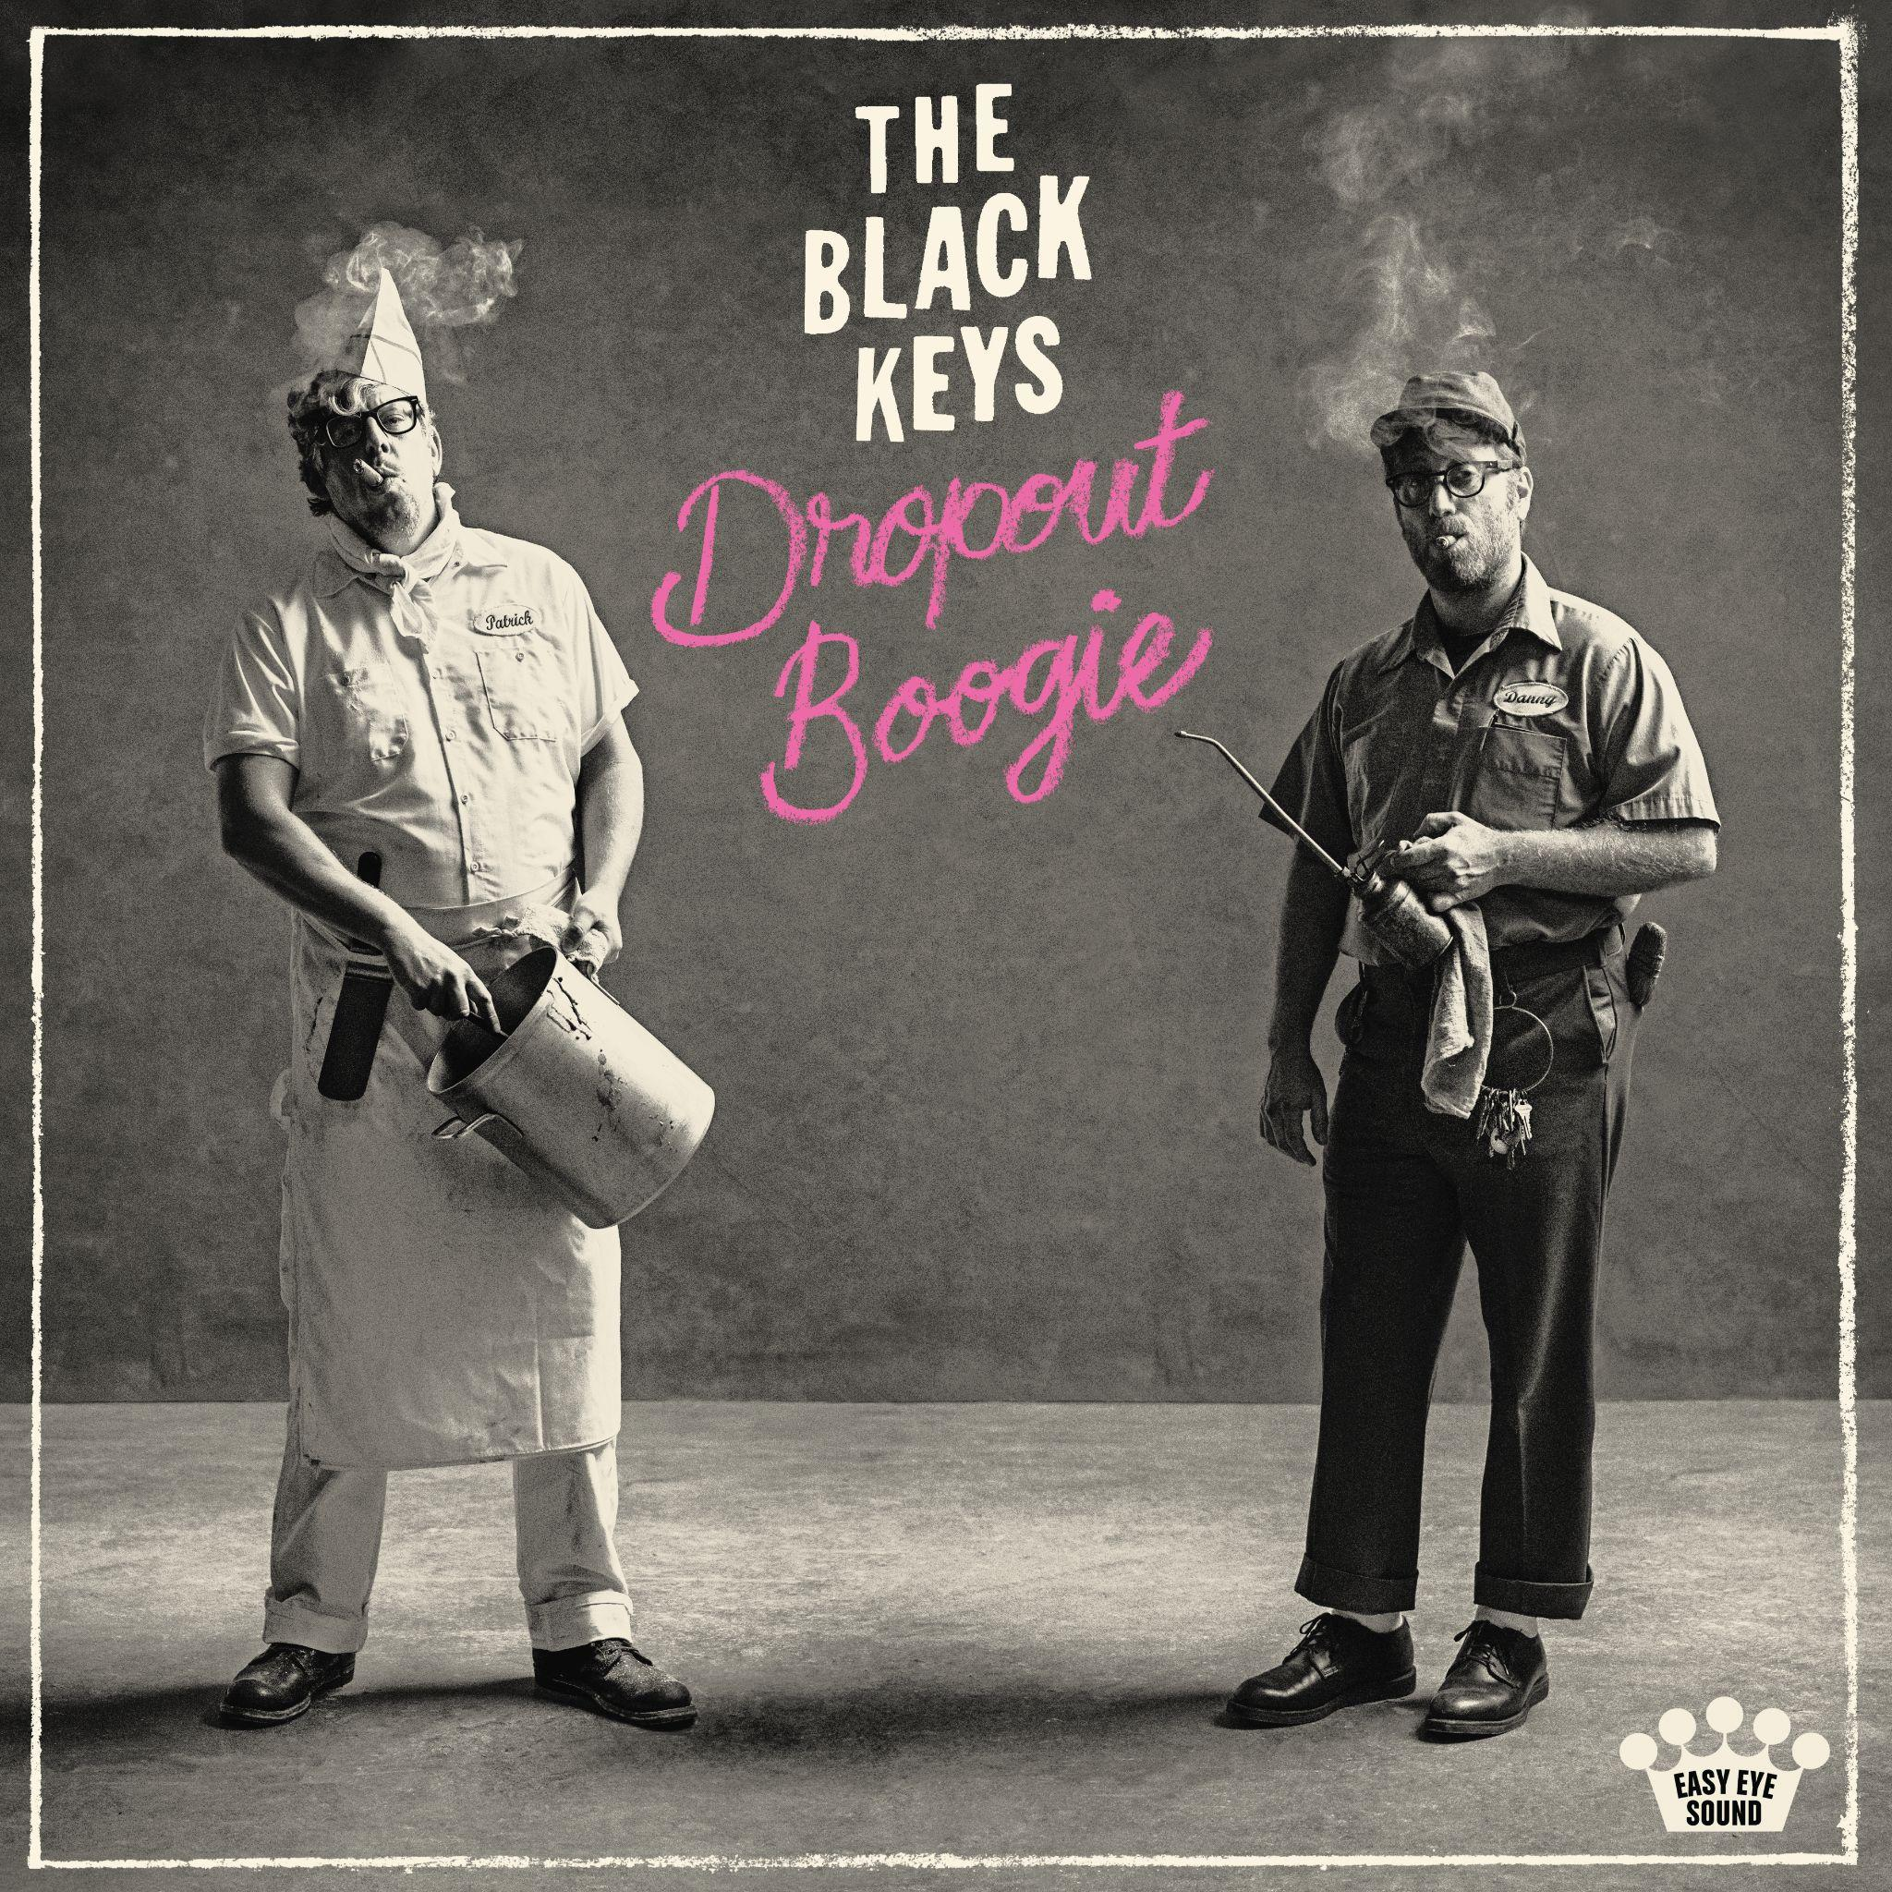
May 13, 2022 - (Los Angeles, CA) - The Black Keys have released their eleventh studio album, Dropout Boogie, on Nonesuch Records. It is available to stream/purchase here. The duo of Dan Auerbach and Patrick Carney will participate in an album release party with iHeart Radio stations across the country at 7pm PT tonight. Audiences can tune in to YouTube.com/iHeartRadio or youtu.be/INgfoIad8pk to watch.

Led by the singles “Wild Child” and “It Ain’t Over,” Dropout Boogie features collaborations with Reigning Sound’s Greg Cartwright, Billy F Gibbons (ZZ Top), and Angelo Petraglia (Kings of Leon) and arrives one day before the twentieth anniversary of The Black Keys’ first LP, The Big Come Up. The new album captures a number of first takes that hark back to the stripped-down blues rock of their early days making music together in Akron, Ohio basements.

Last night, The Black Keys stopped by Jimmy Kimmel Live! for a performance of latest single “It Ain’t Over” and “Wild Child,” which topped Billboard’s AAA chart in April and is current #1 at Alternative and headed back to #1 at AAA this week, and elsewhere around the world the single is proving to be one of the band’s most successful radio hits to date.

Praise for Dropout Boogie:

“Some of the stickiest alt-boogie of their career.” - Rolling Stone

“Still raw, fast and loose” - Associated Press

“Rock'n'roll in 2022 doesn't get any better than this.” - Classic Rock Magazine

“A listen loaded with enough thrills and spills to soundtrack a wild ride down Route 66. This pair are masters in capturing that timeless flair and spirit. They’re the embodiment of a band set for good times.” - NME

The Black Keys will tour North America for the first time in three years starting in July. Band of Horses will support on all dates, while Ceramic Animal (July 9-30), Early James (Aug. 24-Sept. 9), and the Velveteers (Oct. 2-18) will open at select performances. International tour dates will be announced in the coming weeks.

About The Black Keys
Formed in Akron, Ohio in 2001, The Black Keys are singer/guitarist Dan Auerbach and drummer Patrick Carney. Last year, the duo received its fourteenth Grammy nomination, this time for Best Contemporary Blues Album for Delta Kream, which was released in May 2021 by Nonesuch. The project, which features eleven Mississippi hill country blues songs by artists such as R.L. Burnside and Junior Kimbrough, was the band’s fifth consecutive top 10 debut on The Billboard 200. Internationally, Delta Kream was the band’s fourth consecutive top 10 album in the U.K., where it debuted at No. 5. It reached the top 10 in Australia, Austria, Belgium, Finland, France, Germany, Netherlands, New Zealand, Portugal, Spain, Croatia, and Switzerland, among others, and scored career peaks in several countries.

Most recently, The Black Keys released the Super Deluxe 10th anniversary edition of their landmark seventh studio album, El Camino in late 2021. El Camino was produced by Danger Mouse and The Black Keys and was recorded in the band’s then-new hometown of Nashville during the spring of 2011. The Black Keys won three Grammy Awards for El Camino—Best Rock Performance, Best Rock Song, and Best Rock Album—among other worldwide accolades.

The Black Keys have been called “rock royalty” by the Associated Press. Cutting their teeth playing small clubs, the band has gone on to sell out arena tours and has released 10 previous studio albums: its debut The Big Come Up (2002), followed by Thickfreakness (2003) and Rubber Factory (2004), along with their releases on Nonesuch Records, Magic Potion (2006), Attack & Release (2008), Brothers (2010), El Camino (2011), Turn Blue (2014), “Let’s Rock” (2019) and Delta Kream (2021). The band has won six Grammy Awards and a BRIT and headlined festivals in North America, South America, Mexico, Australia, and Europe.

The Black Keys’ Dropout Boogie tour dates and cities:

July 9: Las Vegas, NV – MGM Grand Garden Arena
July 11: Salt Lake City, UT – USANA Amphitheatre
July 13: Denver, CO – Red Rocks Amphitheatre
July 15: St. Louis, MO – Hollywood Casino Amphitheatre St. Louis
July 16: Indianapolis, IN – Ruoff Music Center
July 17: Chicago, IL – Hollywood Casino Amphitheatre Tinley Park
July 20: Saratoga Springs, NY – Saratoga Performing Arts Center
July 22: Jones Beach, NY – Northwell Health at Jones Beach Theater
July 23: Holmdel, NJ – PNC Bank Arts Center
July 25: Columbia, MD – Merriweather Post Pavilion
July 27: Charlotte, NC – PNC Music Pavilion
July 29: Boston, MA – Xfinity Center
July 30: Philadelphia, PA – Waterfront Music Pavilion (formerly BB&T Pavilion)
Aug. 24: West Palm Beach, FL – iTHINK Financial Amphitheatre
Aug. 25: Tampa, FL – MIDFLORIDA Credit Union Amphitheatre
Aug. 27: Atlanta, GA – Ameris Bank Amphitheatre
Aug. 28: Huntsville, AL – Orion Amphitheatre
Aug. 30: Charleston, SC – Credit One Stadium
Sept. 1: Raleigh, NC – Coastal Credit Union Music Park at Walnut Creek
Sept. 3: Cincinnati, OH – Riverbend Music Center
Sept. 6: Toronto, ON – Budweiser Stage
Sept. 7: Detroit, MI – Pine Knob Music Theatre
Sept. 9: Cuyahoga Falls, OH – Blossom Music Center
Oct. 2: Seattle, WA – Climate Pledge Arena
Oct. 3: Vancouver, BC – Rogers Arena
Oct. 5: Mountain View, CA – Shoreline Amphitheatre
Oct. 8: Los Angeles, CA – The Forum
Oct. 10: Phoenix, AZ – Ak-Chin Pavilion
Oct. 13: Rogers, AR – Walmart AMP
Oct. 15: Houston, TX – Cynthia Woods Mitchell Pavilion
Oct. 17: Austin, TX – Moody Center ATX
Oct. 18: Dallas, TX – Dos Equis Pavilion


Press Photo by Jim Herrington | high-res here

Follow The Black Keys here:
https://theblackkeys.com **Twitter **Instagram **Facebook **Youtube

For more information, please contact Grandstand Media:
Kate Jackson - katej@grandstandhq.com
Katie Nelson - katien@grandstandhq.com

For international enquiries, please contact:
Matthew Rankin, +44 207 938 5552 or matthew.rankin@nonesuch.com

For Live Nation Concerts please contact
Monique Sowinski - moniquesowinski@livenation.com

About Live Nation Entertainment
Live Nation Entertainment (NYSE: LYV) is the world’s leading live entertainment company comprised of global market leaders: Ticketmaster, Live Nation Concerts, and Live Nation Sponsorship. For additional information, visit www.livenationentertainment.com.

