Nonesuch Releases John Adams Collected Works, 40-Disc Box Set, Today

Unprecedented comprehensive set includes all of the composer’s recorded works through 2020
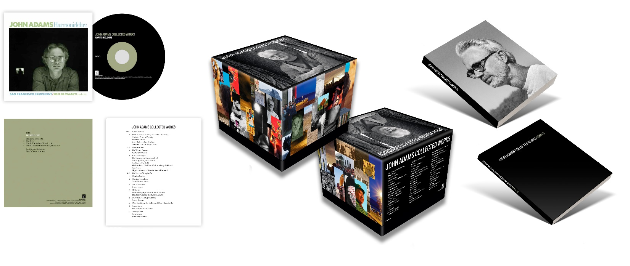
“John Adams has become the leading composer of music today—truly popular, while not denying any of the radicalism of his approach. His music represents not only a symbol for today, but is also a promise of the music of tomorrow.”
—Le Soir * * * * *

Nonesuch Records releases the forty-disc John Adams Collected Works, a box set featuring recordings spanning more than four decades of the composer’s career with the label, today: July 1, 2022. The release includes two extensive booklets containing new essays and notes by Timo Andres, Julia Bullock, Robert Hurwitz, Nico Muhly, and Jake Wilder-Smith. You can watch an unboxing video of the set here.

Nonesuch made its first record with John Adams in 1985. He was signed exclusively to the label that year, and since then the company has released forty-two first recordings and thirty-one all-Adams albums, of which six are full-length operas, oratorios, or staged theatrical presentations. Four of Adams’ Nonesuch records have won Grammy Awards, among other honors.

“John Adams coming to the label was one of the central events in our company’s history,” says Robert Hurwitz, Nonesuch’s longtime President and current Chairman Emeritus. “The idea of a label recording all of the works of its most cherished composers had been long established in the classical record business, most notably the efforts of Columbia with Stravinsky, Decca with Britten, and Deutsche Grammophon with Stockhausen.” With this box, Nonesuch and Adams are now added to that list.

“Every recording was either conducted by John, or made under close supervision of the composer, who was in the control booth for every album—when he wasn’t on the podium,” Hurwitz says.

He continues: “As the record business changed, we realized the urgency of preserving this amazing accomplishment in a physical form; the music’s importance to our culture cannot be overestimated and the idea of much of it only being available digitally in the future was difficult to imagine.

“In making the box we left a little extra space, since Nonesuch plans to continue recording John’s work.”

John Adams occupies a unique position in the world of music. Long embraced by the world’s leading orchestras and conductors, instrumental soloists and singers, choreographers and opera directors, his works are among the most performed of all contemporary classical music. Early in his career, Adams was composer-in-residence of the San Francisco Symphony (1982-85), and creator of the orchestra’s highly successful and controversial New and Unusual Music series. Many of his landmark orchestral works were written for and premiered by the San Francisco Symphony, including Harmonium (1981), Grand Pianola Music (1982), Harmonielehre (1985), and Absolute Jest (2012).

In 1985, Adams began a collaboration with stage director Peter Sellars that has resulted in more than three decades of groundbreaking operas and oratorios: Nixon in China (1987) and The Death of Klinghoffer (1991), both to libretti by Alice Goodman; El Niño (2000), Doctor Atomic (2005); A Flowering Tree (2006); The Gospel According to the Other Mary (2012); and Girls of the Golden West (2017). The LA Phil will perform Girls of the Golden West during the 2022–23 season and will record it for release on Nonesuch.

Since 2009 Adams has held the position of Creative Chair with the Los Angeles Philharmonic where he has been instrumental in the success of that orchestra’s highly creative Green Umbrella new music series.

Adams also has become a significant mentor of the younger generation of American composers. In his liner note, Adams’ label mate, composer and pianist Timo Andres, says: “I don’t think it’s an exaggeration to say that when Road Movies was dropped into my lap as a college freshman, it triggered a chain reaction that led me where I am now … John’s music has been such a constant in my life that it’s reached a base level of my consciousness—it’s part of the way I hear all music now.”

This year launched with a major focus on Adams’ music in Zürich with the Tonhalle Orchestra, from January to March. Orchestras around the world will likewise present major performances of his works including Cincinnati Symphony, NDR Elbphilharmonie, Hong Kong Philharmonic, Budapest Festival Orchestra. This spring, Adams’ piano concerto Must the Devil Have All the Good Tunes? tours to orchestras around the world: Seattle, St. Louis, Cleveland, Zürich, Iceland, Gothenburg, and San Francisco; Adams conducted a performance of it by the Cleveland Orchestra and Jeremy Denk earlier this year. In September 2022, Adams’s new opera Antony & Cleopatra will open the San Francisco Opera’s centennial season.

Nonesuch Records has historically had close relationships with modern composers. During the years of Tracey Sterne, the label made multiple recordings of Elliott Carter, George Crumb, Charles Wuorinen, and William Bolcom. Since 1985, Nonesuch has made multiple recordings of works by Philip Glass, Stephen Sondheim, Laurie Anderson, Caroline Shaw, Louis Andriessen, John Zorn, Adam Guettel, Henryk Górecki, Timo Andres, Nico Muhly, and Donnacha Dennehy. For Steve Reich, like John Adams, Nonesuch has recorded nearly every new piece of his music since 1985 and will also release a collection of his complete works—in 2023.

While Nonesuch recordings comprise thirty-five of the forty discs in Collected Works, the set also includes recordings from other labels, including: the Los Angeles Philharmonic’s recordings of The Gospel According to the Other Mary and Must the Devil Have All the Good Tunes?, with Yuja Wang, on Deutsche Grammophon; a recording by Christina and Michelle Naughton of Roll Over Beethoven on Warner Classics; and the San Francisco Symphony’s recordings of Absolute Jest and Grand Pianola Music. The Berlin Philharmonic’s recording of Harmonielehre, conducted by Adams, is the final CD in the set, serving as the bookend to the piece’s first recording, by the San Francisco Symphony led by Edo de Waart on Nonesuch that is the first disc of the set.

John Adams Collected Works

Disc 1 | Harmonielehre
2 | The Chairman Dances (Foxtrot for Orchestra)  Christian Zeal and Activity  Tromba Lontana  Short Ride in a Fast Machine  Common Tones in Simple Time
3-6 | Nixon in China
7 | The Wound-Dresser  Fearful Symmetries
8 | American Elegies:  The Unanswered Question (Ives)  Five Songs (Ives, orch. Adams)  Fog Tropes (Marshall)  Madame Press Died Last Week at Ninety (Feldman)  Eros Piano  Elegy in Memory of Maurice Ravel (Diamond)
9-10 | The Death of Klinghoffer
11 | Hoodoo Zephyr
12 | Chamber Symphony  Grand Pianola Music
13 | Violin Concerto  Shaker Loops
14 | El Dorado  Berceuse élégiaque (Busoni, orch. Adams)  The Black Gondola (Liszt, orch. Adams)
15 | John’s Book of Alleged Dances  Gnarly Buttons
16 | I Was Looking at the Ceiling and Then I Saw the Sky
17 | Harmonium  The Klinghoffer Choruses
18 | Century Rolls  Lollapalooza  Slonimsky’s Earbox
19-20 | El Niño
21 | Naive and Sentimental Music
22 | Road Movies  Hallelujah Junction  China Gates  American Berserk  Phrygian Gates
23 | On the Transmigration of Souls
24 | The Dharma at Big Sur
25 | My Father Knew Charles Ives
26-27 | A Flowering Tree
28 | Doctor Atomic Symphony  Guide to Strange Places
29 | Son of Chamber Symphony  First Quartet
30-31 | The Gospel According to the Other Mary
32 | City Noir  Saxophone Concerto
33 | Scheherazade.2
34 | Violin Concerto
35-36 | Doctor Atomic
37 | Roll Over Beethoven  I Still Play  Scratchband
38 | Must the Devil Have All the Good Tunes?
39 | Absolute Jest  Grand Pianola Music
40 | Harmonielehre

For more information, visit publicity.nonesuch.com or contact:
Melissa Cusick, Nonesuch Records, 212.707.2912 or melissa.cusick@nonesuch.com
# # # #

