
FOR IMMEDIATE RELEASE

Grammy Award-Winning and Multi-Platinum Selling Artist Michelle Branch Releases Her Latest Album The Trouble With Fever Out Now on Audio Eagle/Nonesuch Records/Warner Records

Branch’s Latest Single and Music Video - “Not My Lover” Out Today

Livestream Branch’s Los Angeles Concert Performance During Her The Trouble With Fever Tour Live From The Troubadour on September 27th – Tickets For Tour Dates and Livestream Available Now


(Photo Credit: Sonya Jasinski)
Download Image HERE

(September 16, 2022 – Nashville, TN) Grammy Award-winning and multi-Platinum selling singer-songwriter, Michelle Branch, has released her fourth solo album, The Trouble With Fever, out today. The passion project, born out of the pandemic lockdown, is a collection of material that shows the evolution of Branch’s sound and a lyrical perspective of an artist whose grounded and relatable sensibilities kept her connected to her fans for over 20 years.

Album: The Trouble With Fever

Also released today, is Michelle’s second single off the record, “Not My Lover,” and its beautifully moody music video. Shot at a local karaoke bar in Nashville, TN and directed by Alexa Stone and Stephen Kinigopoulos (Running Bear Films) - the sultry video shows Michelle and friends taking to the microphone for a girl’s night out as they sing about the cathartic emotions of learning to let go.

“This song is about the mistakes we make and trying to learn from them instead of letting them burn you down. You have the power to change your own narrative. I really wanted it to be reminiscent of Fleetwood Mac sonically.” - Michelle Branch

WATCH: “Not My Lover” Music Video

The Trouble with Fever, co-produced with Patrick Carney (The Black Keys), follows Michelle's critically acclaimed 2017 album, Hopeless Romantic. The time at home in isolation gave her the opportunity to stretch herself creatively – not only in writing every track on the record but also by pushing herself to learn instruments she had little to no experience with.

"I didn’t realize I was making a record at first—it was more just for our own sanity, living in a house with a toddler, getting time together to play music and screw around in the studio,” she says. “It felt like new territory. It really was just Patrick and me together, in a very weird time. And it was surprising to make a record that way, without being told to go to work. It was cool that there were no expectations for it at all. We were in such a safe little creative bubble.” - Michelle Branch

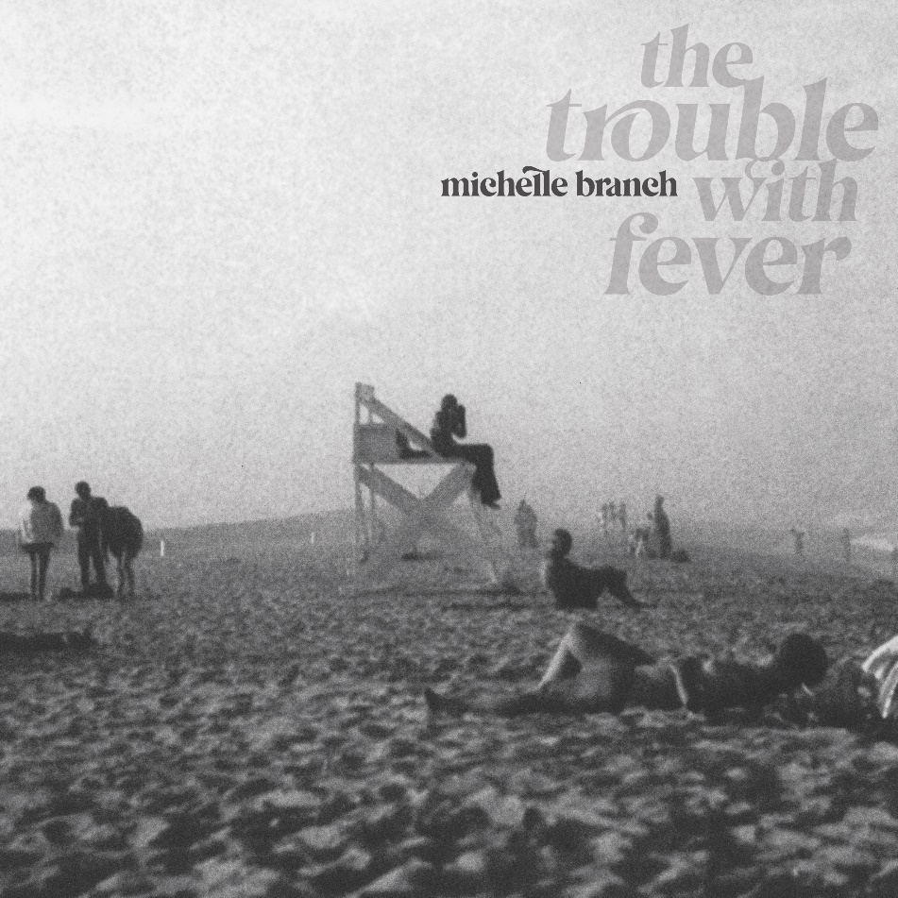
Download Cover Art HERE

“The Trouble With Fever, Branch’s fourth solo album, [is] a candid and captivating meditation on love and identity that continues the impressive artistic growth of the former teen star…” -Billboard

The Trouble with Fever:

- Closest Thing To Heaven
- You Got Me Where You Want Me
- I’m A Man
- Not My Lover
- When That Somebody Is You
- You
- Zut Alors
- Fever Forever
- Beating on the Outside
- I’m Sorry

This Fall, Michelle is kicking off her The Trouble With Fever Tour on September 15th in Boston. Eager to be back touring and performing for fans, Michelle will play songs from her latest album as well as the hits that made her a voice of a generation.
Fans from all over (including internationally) will also have the chance to see Michelle’s final show during this run, as she livestreams her closing performance at the famed Troubadour in Los Angeles on September 27th. Tickets for the livestream (with 24 hour replay) are available now and can be found here.

The Trouble with Fever Tour Dates:

9.17 | Brooklyn Bowl | Philadelphia, PA
9.18 | Webster Hall | New York, NY
9.19 | 9:30 Club | Washington, D.C.
9.21 | Park West | Chicago, IL
9.24 | The Fillmore | San Francisco, CA
9.26 | Troubadour | Los Angeles, CA
9.27 | Troubadour | Los Angeles, CA

Tickets for The Trouble with Fever Tour are on-sale now here.

About Michelle Branch:

Branch was seventeen years old when she signed to Madonna’s Maverick Records. In 2001, she released her highly acclaimed debut album, The Spirit Room, which featured the hit singles “Everywhere” (MTV Video Music Award Viewer's Choice winner), “All You Wanted” and “Goodbye to You”, and ushered in a new era of young women writing and performing their own songs. The album went on to sell three million copies worldwide, and was certified double-Platinum in the US, Platinum in Japan, Gold in Australia and Canada, and Silver in the UK, among others. Branch won a Grammy Award for her 2002 collaboration with Carlos Santana, “The Game of Love,” which peaked at No. 5 on Billboard’s Hot 100, No. 1 on the Billboard Adult Contemporary chart, and was a major international hit. Her second album, 2003’s Hotel Paper, debuted at No. 2 on the US Billboard album chart and was a top 10 hit around world. Certified Platinum in the US, and Gold in Australia, Canada and Japan, it spawned the hit single “Are You Happy Now?,” which was nominated for a Grammy for Best Female Rock Performance (she was also nominated for Best New Artist). In 2006, Branch found success with Jessica Harp as modern-country duo The Wreckers, whose debut Stand Still, Look Pretty was praised by critics for breaking down barriers between pop and country. The Gold-certified album included the hit single “Leave the Pieces,” which topped the Hot Country Songs chart for several weeks, and earned Branch her fourth Grammy nomination, as well as “My Oh My” and “Tennessee”. In 2017, Branch released her critically acclaimed fourth album, Hopeless Romantic (Verve), co-produced with her husband Patrick Carney (The Black Keys). Paste said of it, “Sprinkled with gorgeous, transparent and colorful synths, Hopeless Romantic casts Branch as a newly matured lover and songwriter and is indeed likely to succeed at satisfying diehards and welcoming in new devotees.”

For additional information on Michelle Branch, including upcoming performance dates, please visit:

Website
Instagram
Facebook
Twitter
YouTube

Media Contacts:

Marcel Pariseau
marcel@truepublicrelations.com

Taylor Bailey
taylor@truepublicrelations.com

For international enquiries, please contact:

Matthew Rankin, Nonesuch Records
matthew.rankin@nonesuch.com

