Nonesuch Releases k.d. lang’s tribute to Tony Bennett, “Because of You,” on August 17

Proceeds from recording of song made famous by Bennett to benefit Exploring the Arts’ Tony Bennett Legacy Fund

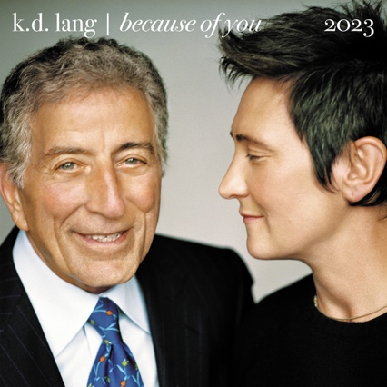
Photographer: Mark Seliger

k.d. lang recently recorded the song that was Tony Bennett’s first no. 1 hit, “Because of You,” for CBS News Sunday Morning, in memory of her longtime friend, teacher, and musical collaborator. Nonesuch releases the recording today, August 17, 2023; lang is donating her proceeds to the Tony Bennett Legacy Fund of Exploring the Arts, the nonprofit he and his wife Susan Benedetto founded. Bennett and lang recorded Arthur Hammerstein and Dudley Wilkinson’s song together for his 2006 album Duets: An American Classic. lang's new version was recorded at NightBird Studios in West Hollywood, CA. Dae Bennett, who mixed Tony Bennett and k.d. lang’s Grammy–winning 2002 album A Wonderful World, mixed this recording of “Because of You.” lang also wrote a tribute to Bennett that appears in today’s Guardian.

“The indelible imprint of this man. How can we possibly express our gratitude? Only perhaps by understanding the power of a good song, and the generosity of a great singer,” lang said.

“‘Because of You’ was the last song Tony sang, just two days before he passed,” Benedetto said. “Hearing k.d.’s beautiful rendition of the song she and Tony sang together brings back wonderful memories and pays tribute to their friendship. As I mentioned to k.d., ‘If Tony were here, he would say only one word after hearing you sing that song, ‘Perfect.’

“I am so moved that k.d. would honor Tony’s legacy by releasing this version and donating her proceeds to Exploring the Arts, which Tony and I founded to give young people access to arts education.”

Exploring the Arts’ work reflects Tony Bennett’s profound belief that every student in every school must have access to the arts. The arts, as Bennett said, “make people better human beings” and provide them with the foundation to be the individuals they dream of becoming. The Tony Bennett Legacy Fund, launched to honor his vision and passion, will ensure ETA can sustain and grow the important work he and Benedetto started twenty-five years ago.

One a legendary artist and humanitarian, the other a dedicated teacher and champion of public schools, together Bennett and Benedetto committed to restoring the arts in American classrooms. It began with their dream to create Frank Sinatra School of the Arts in Tony Bennett's hometown of Astoria, Queens, a high school for the City's children that has consistently delivered excellent results while nurturing creativity and commitment to craft. ETA has since grown from serving one city to now two, from serving one school to now 56 schools on both coasts ... and counting.

k.d. lang’s distinguished career includes four Grammy and eight Juno Awards. In addition to her fruitful collaboration with Bennett (who called her “the best singer of her generation”), lang has performed alongside luminaries including Roy Orbison, Bonnie Raitt, Elton John, and Loretta Lynn. She sang at the closing ceremonies of the 1988 Winter Olympics in Calgary and the opening ceremonies of the 2010 Vancouver Winter Olympics. lang has contributed music to the soundtracks of several films, including Even Cowgirls Get the Blues, Midnight in the Garden of Good and Evil, and Happy Feet. She has also appeared in a number of films, including Salmonberries, The Black Dahlia, and Eye of the Beholder. In 1996, lang received Canada’s highest civilian honor, the Order of Canada, and she was awarded a Lifetime Artistic Achievement prize at the Governor General's Performing Arts Awards in 2023.

lang released her first album with Nonesuch Records in 2004, the acclaimed and highly personal “Canadian songbook,” Hymns of the 49th Parallel, featuring work by Joni Mitchell, Leonard Cohen, Neil Young, Jane Siberry, and others. Her subsequent releases on the label include Watershed (2008), her first career retrospective Recollection (2010), Sing It Loud (2011), and Ingénue: 25th Anniversary Edition in 2017, comprising lang’s multi-platinum, Grammy Award–winning original album, as well as the previously unreleased 1993 MTV Unplugged performances. To coincide with the anniversary, lang performed sold-out concerts in Canada, the US, Australia, UK, and Ireland; a DVD of the show, Ingenue Redux: Live from The Majestic Theatre, was released in 2018. “Because of You” is her first new recording since the previously unreleased “Sleeping Alone” on that DVD. Most recently, Nonesuch released makeover, a new collection of classic dance remixes of some of lang’s best-loved songs in 2021. k.d. lang and Tony Bennett first worked together in 1994, when he invited her to perform “Moonglow” with him for his MTV Unplugged episode and album.

For more information, visit publicity.nonesuch.com, or contact:
Melissa Cusick, melissa.cusick@nonesuch.com

For international enquiries, please contact:
Matthew Rankin, matthew.rankin@nonesuch.com

# # # #

