Nonesuch Records Releases Darcy James Argue’s Secret Society Label Debut,
Dynamic Maximum Tension, Today

Album release to be celebrated at New York City’s Jazz Gallery September 13-16

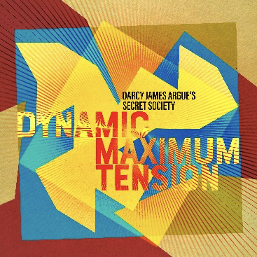

“The range of different colours and textures Argue gets from the ensemble is astonishing… bravura ... large ensemble writing that proves just how nimble a big band can be in the right hands.” —Jazzwise

“Argue’s Secret Society … [is] one of the most exciting large ensembles working in jazz today.” —Wall St. Journal

“Remarkable in its ambition, scope and sheer length, this is Argue’s crowning achievement to date.”
—New York City Jazz Record

Nonesuch Records releases composer and bandleader Darcy James Argue and his Secret Society ensemble’s label debut, Dynamic Maximum Tension, today: September 8, 2023. The album, which All About Jazz calls “superb” and “a delight,” pays homage to some of Argue’s key influences with original songs dedicated to R. Buckminster Fuller, Alan Turing, and Mae West, among others. Argue and Secret Society celebrate the release of Dynamic Maximum Tension with a four-night run at New York City’s Jazz Gallery next week, September 13 through 16. More information and tickets are available here. A video about the making of Dynamic Maximum Tension—filmed at Power Station at BerkleeNYC in New York City during the album’s recording, narrated by Argue, and directed by Reuben Hernandez—may be seen here.

Of his inspiration for the album, Argue says: “It feels like our culture today is headed in a profoundly dystopian direction. By engaging with figures like Buckminster Fuller, Alan Turing, and Mae West, I was trying to connect to a more optimistic time, trying to reclaim a sense of agency, trying to rekindle my faith in our ability to grab the future and shape it ourselves.”

Darcy James Argue, “one of the top big band composers of our time” (Stereophile), is best known for Secret Society, an eighteen-piece group “renowned in the jazz world” (New York Times). Argue brings an outwardly anachronistic ensemble into the 21st century through his “ability to combine his love of jazz’s past with more contemporary sonics” and is celebrated as “a syncretic creator who avoids obvious imitation” (Pitchfork).

Acclaimed as an “innovative composer, arranger, and big band leader” by the New Yorker, Argue’s accolades include multiple GRAMMY nominations and a Latin GRAMMY Award, a Guggenheim Fellowship, a Doris Duke Artist Award, and countless commissions and fellowships. His prescient 2016 Real Enemies, an album-length exploration of the politics of paranoia, was named one of the twenty best jazz albums of the decade by Stereogum. Like Real Enemies, Argue’s previous recordings—his debut Infernal Machines and his follow-up, Brooklyn Babylon—were nominated for both GRAMMY and JUNO awards.

Darcy James Argue
Dynamic Maximum Tension

- Dymaxion
- All In
- Ebonite
- Last Waltz for Levon
- Wingèd Beasts
- Your Enemies Are Asleep
- Codebreaker
- Ferromagnetic
- Single-Cell Jitterbug
- Tensile Curves
- Mae West: Advice

All compositions by Darcy James Argue, except “Mae West: Advice” by Darcy James Argue (music) and Paisley Rekdal (lyrics)

For more information, please visit publicity.nonesuch.com or contact:
Melissa Cusick, melissa.cusick@nonesuch.com

For international enquiries, please contact:
Matthew Rankin, matthew.rankin@nonesuch.com

# # # #

