Yussef Dayes Releases Debut Solo Album, Black Classical Music, Today

Visualizer for album track “Pon Di Plaza” with Chronixx also released

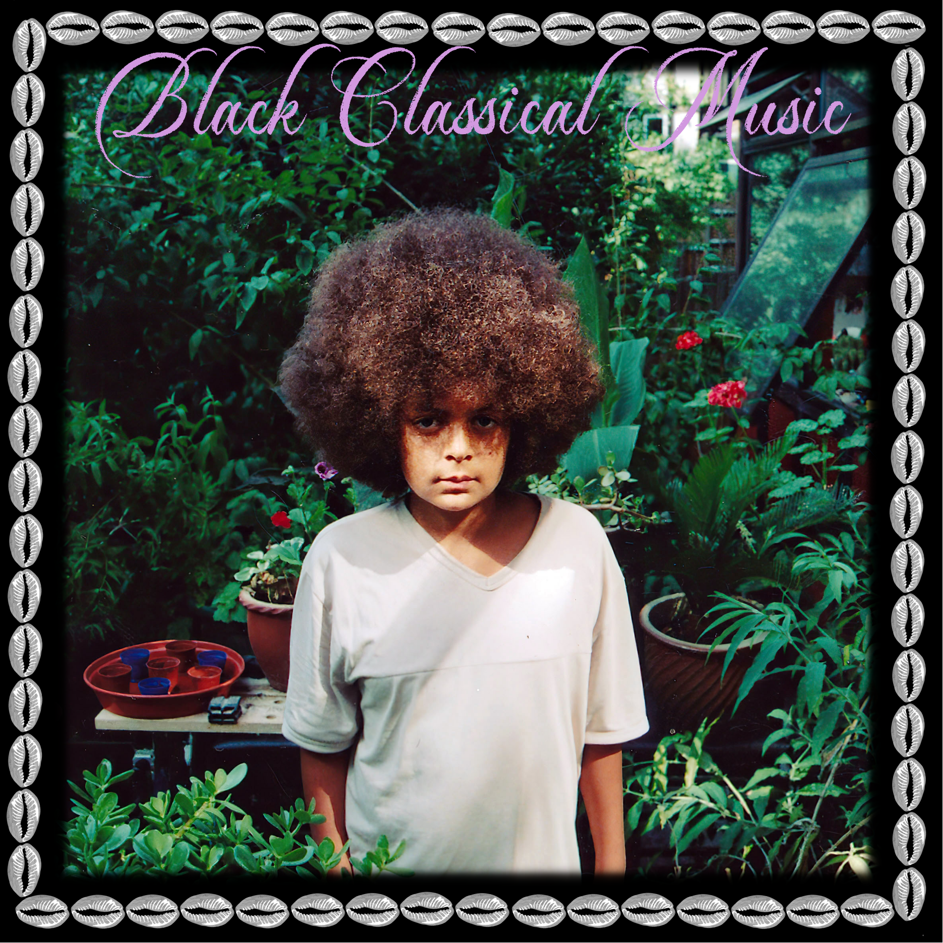

“This album is an absolute feast” —NPR Music

“One of the most exciting jazz drummers and composers to emerge in recent years” —KEXP

“An album that reflects the London-based artist's deep, funky, soulful, muscular live performances … It's Yussef's big statement and one that puts him in a great line of artists evolving what it means to be a Black musician, what it means to play jazz, to incorporate soul, funk, rock, and anything else he wants to into what he's calling Black classical music.” —Andrew Jervis, Bandcamp Weekly

Multi-instrumentalist, producer, and composer Yussef Dayes releases his debut solo album, Black Classical Music, today—September 8, 2023—via Brownswood Recordings, Warner Music, and Cashmere Thoughts Recordings and in the US on Nonesuch Records. A visualizer for the album track “Pon Di Plaza,” featuring vocal and instrumental contributions from esteemed Jamaican singer Chronixx, was released yesterday and may be seen here. Dayes will bring music from the new album to the UK in October, including a show at London’s Royal Albert Hall on October 12, before heading out on a tour of the United States in November and December. A complete list of dates may be found below.

“My debut album and an art piece that has been in the works since the beginning,” says Dayes of Black Classical Music. “Feelings of love, healing, grief, inspiration, more life, unity, groove, spirit and travels. This album is the embodiment of my life to this point. For everyone that has supported my art or is discovering my music now, I am grateful to be able to share this with you. Thank you to my team and all of the collaborators for helping me bring this vision to life. Sharing vibes and sounds from the UK, rooted in the gumbo pot of the Caribbean, South American culture & African rituals. Black Classical Music is an exploration of my own personal journey & musical style.”

Black Classical Music is Yussef Dayes’ nineteen-track debut solo studio album. His drum licks and Rocco Palladino’s bass are the sturdy anchors, aided by Charlie Stacey (keys/synths), Venna (saxophone), Alexander Bourt (percussion), and a host of features including: Chronixx, Masego, Jamilah Barry, Tom Misch, Elijah Fox, Shabaka Hutchings, Miles James, Sheila Maurice Grey, Nathaniel Cross, Theon Cross, and the Chineke! Orchestra—the first professional orchestra in Europe to be made up of majority Black and ethnically diverse musicians.

Dayes’ career is expansive and wide reaching; his rise can be first linked to the Afrocentric quartet, United Vibrations, alongside his two brothers, Ahmad and Kareem, and saxophonist, Wayne Francis. This was followed by the highly successful but short-lived duo Yussef Kamaal, with keyboardist Kamaal Williams. More recently, Dayes released Live at Joshua Tree, an EP presented by Soulection, and other solo releases including the live album Welcome to the Hills and Love Is the Message, which was recorded live at Abbey Road Studios.

His extensive list of collaborators includes the finest talents across both music and fashion—from 2020’s Top 5-charting collaboration with Tom Misch What Kinda Music (Blue Note) to an official remix of Pa Salieu’s “Frontline” on Wizkid’s “Made in Lagos” album to production for R&B royalty in Kali Uchis and Kehlani. Dayes had a special artistic relationship with the late Louis Vuitton innovator, Virgil Abloh, who hand-picked him to soundtrack and curate a LV dinner show for Paris Men’s Fashion Week and invited him to perform at the Louis Vuitton Museum in Paris, among many other collaborations. More recently, Dayes has lent his musical prowess to albums from the likes of Sampha and Noname, further solidifying his position as a respected and sought-after collaborator.

BLACK CLASSICAL MUSIC
- Black Classical Music (feat. Venna & Charlie Stacey)
- Afro Cubanism
- Raisins Under The Sun (feat. Shabaka Hutchings)
- Rust (feat. Tom Misch)
- Turquoise Galaxy
- The Light (feat. Bahia Dayes)
- Pon Di Plaza (feat. Chronixx)
- Magnolia Symphony
- Early Dayes
- Chasing The Drum
- Birds of Paradise
- Gelato
- Marching Band (feat. Masego)
- Crystal Palace Park (feat. Elijah Fox)
- Presidential (feat. Jahaan Sweet)
- Jukebox
- Woman’s Touch (feat. Jamilah Barry)
- Tioga Pass (feat. Rocco Palladino)
- Cowrie Charms (feat. Leon Thomas & Barbara Hicks)

YUSSEF DAYES ON TOUR
Oct 3, Concorde II, Brighton, UK
Oct 4, Tramsheds, Cardiff, UK
Oct 6, SWX, Bristol, UK
Oct 7, New Century, Manchester, UK
Oct 8, Liquid Rooms, Edinburgh, UK
Oct 12, Royal Albert Hall, London, UK

Nov 16, Warsaw, Brooklyn, NY
Nov 17, Royale, Boston, MA
Nov 18, Union Transfer, Philadelphia, PA
Nov 19, Irving Plaza, New York, NY
Nov 21, El Club, Detroit, MI
Nov 22, Thalia Hall, Chicago, IL
Nov 24, Variety Playhouse, Atlanta, GA
Nov 25, Neighbourhood Theatre, Charlotte, NC
Nov 26, City Winery, Nashville, TN
Nov 28, The Showbox, Seattle, WA
Nov 30, Revolution Hall, Portland, OR
Dec 3, The Fonda, Los Angeles, CA
Dec 4, Crescent Ballroom, Phoenix, AZ
Dec 6, Cervantes’ Masterpiece, Denver, CO
Dec 8, Oasis Wynwood, Miami, FL
Dec 12, Tipitina’s, New Orleans, LA
Dec 13, Rise Rooftop, Houston, TX
Dec 14, Empire Garage, Austin, TX
Dec 15, Studio at the Factory, Dallas, TX
Dec 17, Fine Line, Minneapolis, MN

For more information, please visit publicity.nonesuch.com or contact:
Chad DePasquale, chad.depasquale@nonesuch.com

For international enquiries, please contact:
Chris Cuff, chris.cuff@goodmachinepr.com

CONNECT WITH YUSSEF DAYES
INSTAGRAM | YOUTUBE | TWITTER | FACEBOOK

# # # #

