Nonesuch Releases Donnacha Dennehy’s Land of Winter,
Performed by Alarm Will Sound and Alan Pierson, on November 15

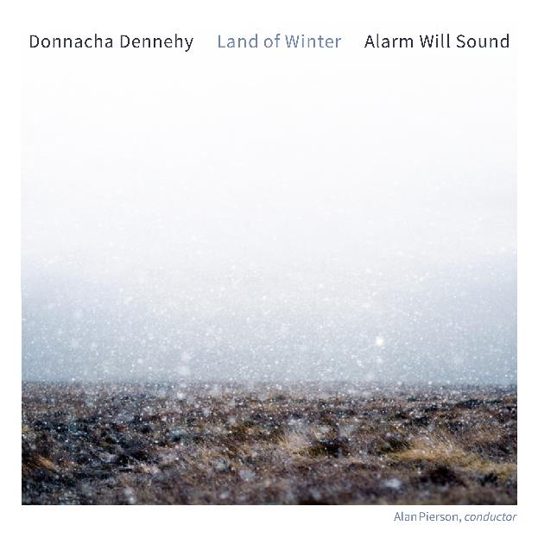

“Donnacha Dennehy has a soundworld all of his own.” —The Wire
Nonesuch Records releases Donnacha Dennehy’s Land of Winter on November 15, 2024. The piece, performed by Dennehy’s longtime collaborators Alarm Will Sound and conductor Alan Pierson, explores the subtleties of Ireland’s seasons via twelve connected sections representing the months of the year. The album track “November,” along with a video, is available today. Alarm Will Sound performs Land of Winter at New York City’s Irish Arts Center on December 11 and 12.

Dennehy says of his composition, “The Romans referred to Ireland as Hibernia—the ‘land of winter’—believing that the inhabited world ended in the northwest with this country that never knew summer ... It is the varying quality of light that truly demarcates the seasons, from the shorter days of grey or piercing light in the winter to the warmer but mercurial light of summer days that at solstice stretch almost to midnight. I like this play between light and time, and it is the major inspiration behind the piece.

“Structurally, the piece is divided into twelve ‘months’ continuously connected, beginning in December, and culminating at the end of November, ready to start all over again in winter,” he continues. “Solstices and equinoxes are translated musically using overtone distributions throughout the ensemble, creating sweeps of color and shade across the aural space.”

Called “thrilling” by the Guardian, and “arrestingly beautiful” by the New Yorker, Donnacha Dennehy’s music has been featured in festivals and venues such as Carnegie Hall, Barbican, MusikFest Berlin, Muziekgebouw, Wigmore Hall, Royal Opera House, BAM, St. Ann’s Warehouse, Kennedy Center, ISCM World Music Days, Musica Viva, and the Bang On A Can, Edinburgh International, Tanglewood, Holland, Huddersfield Contemporary Music, Dublin Theatre, Ultima, Saarbrucken, and Schleswig-Holstein Festivals.

Dennehy’s music has been premiered and commissioned by groups and soloists including Augustin Hadelich, Contact, Crash Ensemble, Dawn Upshaw, Kronos Quartet, Icebreaker, Nadia Sirota, National Symphony Orchestra of Ireland, Oregon Symphony, Sō Percussion (Carnegie/Cork Opera House co-commission), St. Paul Chamber Orchestra, and Third Coast Percussion. Collaborations include pieces with the writers Colm Tóibín (The Dark Places), the director Tom Creed (The Hunger, stage version), and Enda Walsh (a trilogy of operas). Land of Winter is the third album of Dennehy’s music on Nonesuch Records, including Grá Agus Bás in 2011 and The Hunger, also featuring Alarm Will Sound, in 2019.

Alarm Will Sound is a twenty-member touring ensemble led by Artistic Director Alan Pierson that commissions, performs, and records innovative works by established and emerging composers, especially works that incorporate theatrical and multimedia elements by choreographers, visual artists, designers, and directors. Described by the New York Times as “as close to being a rock band as a chamber orchestra can be,” its wideranging artistic vision looks beyond genre—electronic vs. acoustic, high-modernist vs. pop-influenced, conventional classical concert vs. multimedia experience. The ensemble has been featured on two previous Nonesuch recordings: Donnacha Dennehy’s The Hunger and 2009’s a/rhythmia, performing fourteen pieces from composers spanning six centuries.

Alan Pierson has been praised as “a dynamic conductor and musical visionary” by the New York Times. He is the Artistic Director and conductor of the acclaimed ensemble Alarm Will Sound which has been called “a sensational force” with “powerful ideas about how to renovate the concert experience” by the New Yorker. Pierson served for three years as the Artistic Director and conductor of the Brooklyn Philharmonic. He has also appeared as a guest conductor with the Los Angeles Philharmonic, the Chicago Symphony Orchestra, the Hamburg Symphony Orchestra, L.A. Opera, the London Sinfonietta, the Steve Reich Ensemble, the Orchestra of St. Luke’s, Carnegie Hall’s Ensemble ACJW, the Tanglewood Music Center Orchestra, the New World Symphony, and the Silk Road Project, among other ensembles. He is Principal Conductor of the Dublin-based Crash Ensemble, co-director of the Northwestern University Contemporary Music Ensemble, and has been a visiting faculty conductor at the Indiana University Jacobs School of Music and the Eastman School of Music. He regularly collaborates with major composers and performers, including Yo-Yo Ma, Steve Reich, Dawn Upshaw, Osvaldo Golijov, John Adams, Augusta Read Thomas, David Lang, Michael Gordon, Donnacha Dennehy, La Monte Young, Iarla Ó Lionáird, and choreographers Mark Morris, John Heginbotham, Akram Khan, and Elliot Feld.

For more information, please visit publicity.nonesuch.com, or contact:
Melissa Cusick, Nonesuch Records, melissa.cusick@nonesuch.com or 212.707.2912

# # # #

