Molly Tuttle & Golden Highway’s Into the Wild EP Out Now on Nonesuch Records

EP follows their Grammy-winning 2023 album, City of Gold; Band continues North American tour throughout fall

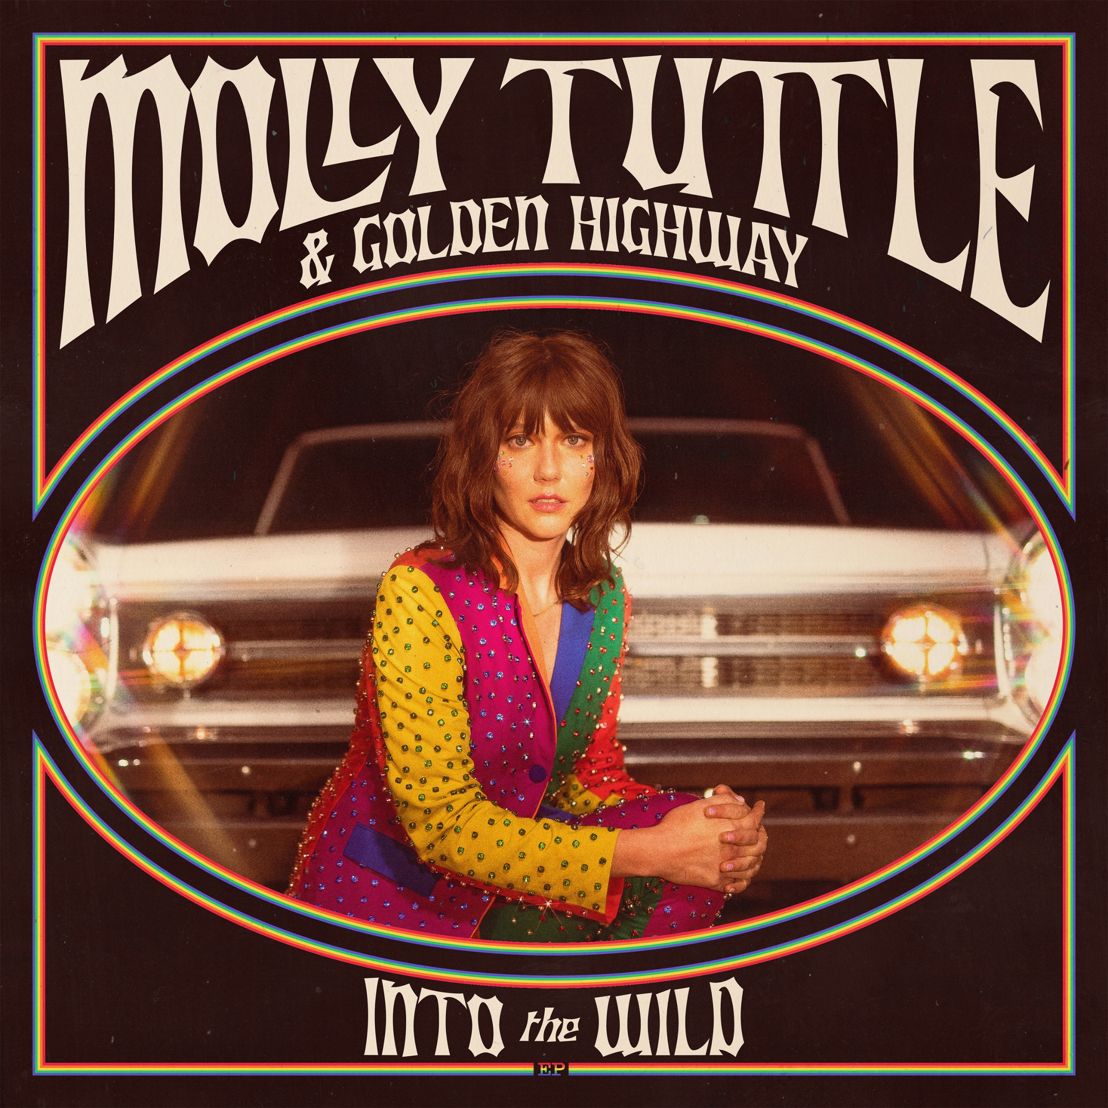

“A virtuoso guitarist with a galvanising charm that electrifies her audience” —Guardian

“A vibrant blend of bluegrass with flashes of Old West, anchored by Tuttle’s earthy-yet-angelic vocal and the entire group’s ace musicianship.” —Billboard

“At this point, Tuttle and Golden Highway are must-hear attractions.” —Bandcamp Daily

Molly Tuttle & Golden Highway’s new six-song EP, Into the Wild, is available today, September 20, 2024, via Nonesuch Records. The EP, a follow-up to their Grammy-winning and critically acclaimed 2023 album, City of Gold, includes three new songs—the title track, “Getaway Girl,” and a cover of Kate Wolf’s “Here in California”—as well as previously released covers of Jefferson Airplane’s “White Rabbit” and Olivia Rodrigo’s “good 4 u” and an alternate version of the City of Gold track “Stranger Things.”

The band continues their North American tour with festival sets this weekend at Bourbon & Beyond in Louisville, Kentucky; Sing Out Loud Festival in St. Augustine, Florida; and FreshGrass in North Adams, Massachusetts. They perform at San Francisco’s Hardly Strictly Bluegrass in October, where they will be joined by Steve Earle, before embarking on a run of newly announced US headline dates in November, including stops in North Carolina, Virginia, upstate New York, Vermont, Massachusetts, and more. A complete list of dates may be found below. Details and tickets are available here.

Of the new release, Tuttle says: “With this new EP we invite you to come on a journey with us Into the Wild. I wrote the title track with Ketch Secor after a week spent in the redwoods. This song is about getting lost in the wilderness even if it’s just in the forest of your mind. ‘Getaway Girl’ was an unfinished song I had started writing for our last LP City of Gold. It’s about a whirlwind romance set in New York City, kind of like Carrie Bradshaw meets bluegrass. In addition to these two new original songs, we included some of our favorite covers that we’ve woven into the live show, ‘White Rabbit’ by Jefferson Airplane and ‘good 4 u’ by Olivia Rodrigo.”
She continues: “We paid tribute to one of my favorite California songwriters Kate Wolf with a new version of her song ‘Here in California’ which features my dad, Jack Tuttle, and longtime friend AJ Lee singing with me. I used to play this one with my family band back in the day! On ‘Stranger Things’ (Down the Rabbit Hole Version) I wanted to go for a stripped back ethereal version of this song originally played by the full band on City of Gold. It features a trio with Dominick Leslie on mandolin, and Nathaniel Smith on cello and synth. I hope you enjoy trekking deeper into the woods with us as we pick up where we left off on City of Gold and explore new territory as a band.”

Earlier this year, Tuttle and the band—fiddler Bronwyn Keith-Hynes, mandolinist Dominick Leslie, bass player Shelby Means, and banjo player Kyle Tuttle—earned their second consecutive GRAMMY win for Best Bluegrass album for City of Gold. Earlier this month, the band was nominated for eight IBMA Bluegrass Music Awards: Tuttle and the band are up for Entertainer of the Year, Vocal Group of the Year, Instrumental Group of the Year, and Album of the Year for City of Gold; Tuttle is nominated for both Female Vocalist of the Year and Guitar Player of the Year, and Bronwyn Keith-Hynes for Fiddle Player of the Year and New Artist of the Year. Additionally, Jerry Douglas, who produced City of Gold with Tuttle and is up for Resophonic Guitar Player of the Year, will be inducted into the Bluegrass Hall of Fame.

Raised in Northern California, Tuttle moved to Nashville in 2015. In the years since, she has received many accolades; in addition to the two GRAMMY wins she was also nominated for Best New Artist. She has earned three wins at the 2023 IBMA Bluegrass Music Awards and Tuttle won Album of the Year at the 2023 International Folk Music Awards. Additionally, she has earned Instrumentalist of the Year at the 2018 Americana Music Awards, and Guitar Player of the Year at the IBMAs in both 2017 and 2018. Tuttle has performed around the world, including shows with Billy Strings, Béla Fleck, Hiss Golden Messenger, Jason Isbell, Old Crow Medicine Show, and Dwight Yoakam, as well as at several major festivals including Newport Folk and Pilgrimage.

MOLLY TUTLE & GOLDEN HIGHWAY ON TOUR
September 20 — Bourbon & Beyond — Louisville, KY
September 21 – Sing Out Loud Festival – St. Augustine, FL
September 22 – FreshGrass – North Adams, MA
September 28 – Billy Strings: Renewal 2024 – Buena Vista, CO
October 3 – Tower Theatre of the Performing Arts – Fresno, CA
October 4 – Hardly Strictly Bluegrass – San Francisco, CA
October 5 – Hardly Strictly Bluegrass – San Francisco, CA*
October 11 – Suwannee Roots Revival – Live Oak, FL
November 2 – Dreamy Draw Music Festival – Scottsdale, AZ
November 3 – Moon Crush Cowboy Moon – Miramar Beach, FL
November 13 – The Orange Peel – Asheville, NC
November 14 – The Underground – Charlotte, NC
November 15 – Jefferson Theater – Charlottesville, VA
November 16 – The Fillmore – Silver Spring, MD
November 17 – Tarrytown Music Hall – Tarrytown, NY
November 19 – The Warehouse at FTC – Fairfield, CT
November 21 – Higher Ground Ballroom – South Burlington, VT
November 22 – Groton Hill Music Center – Groton, MA
November 23 – Electric City – Buffalo, NY
November 24 – Donnell Theater, Marathon Center for the Performing Arts – Findlay, OH
December 6 – Campbell Hall – Santa Barbara, CA
December 12-16 – Strings & Sol – Puerto Morelos, MEXICO

* w/Steve Earle

For more information, please visit publicity.nonesuch.com, or contact:
Melissa Cusick, melissa.cusick@nonesuch.com

# # # #

