JEFF PARKER RELEASES ETA IVtet ALBUM
THE WAY OUT OF EASY
ON ALL STREAMING PLATFORMS VIA INTERNATIONAL ANTHEM / NONESUCH
LISTEN HERE
PARKER AND ETA IVtet TO PERFORM IN LA
DECEMBER 16 + 17 @ ZEBULON

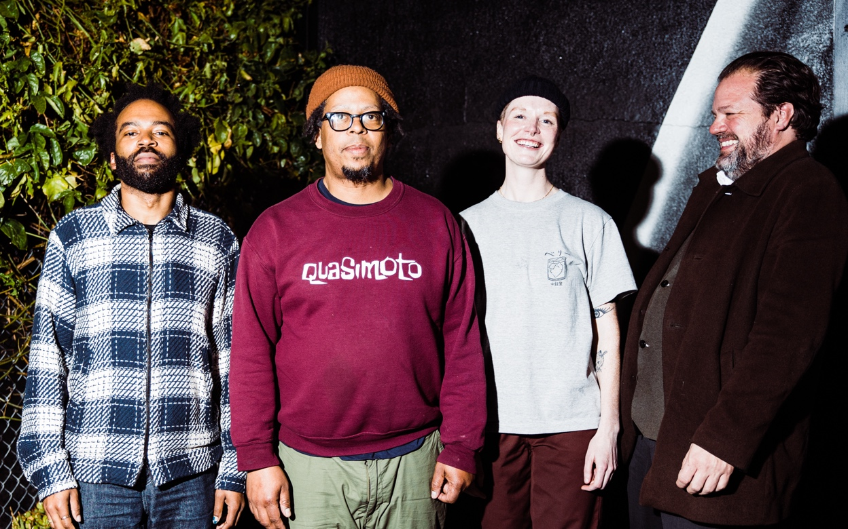
Photo by David Haskell
DOWNLOAD ASSETS
PRAISE FOR JEFF PARKER & THE WAY OUT OF EASY
"The vibe is laid-back, but it rewards rapt attention...This exceptional record fixes your attention on the present moment."
Pitchfork, Best New Music
"There’s no rush, no showing off, just a shared curiosity."
The New York Times
"A testament to the power of live jazz – a mercurial form that captivates when in the right hands."
The Observer
“A believably brilliant measurement of craft...the ETA IVtet sprawl beautifully through contrasts and collisions."
Paste
"An array of sounds, including big fat grooves, hazy ambience, spooky dub, and exploratory solos. Throughout the band demonstrates how patient, tight, adaptable, and transcendent they can be."
Aquarium Drunkard
“[The Way Out of Easy] is really a cool thing to have in your body of work. It'll touch people for a long time. There's nothing else like it.”
Flea, in conversation with Jeff Parker for GQ
“Groove-oriented, painterly, polyrhythmic, minimalist and mantric improvised music — rather like meditation through motion.”
WNYC New Sounds
“‘Freakadelic’ is a slowly building saga of understated, psychedelic funk fusion.”
The FADER
“Extends the quartet's musical vocabulary and sonic identity. While they may not be able to play ETA any longer, their musical signature and group communication prove they can make magic anywhere.”
AllMusic
“One of the most thrilling passages of music you’ll hear all year, the kind of music that makes you thankful that music exists.”
Molars
“’Late Autumn,’ a collectively and spontaneously composed piece, begins with gentle solo guitar from Parker, before Johnson, Butterss, and Bellerose gradually slide in around him, the drummer seeming to do the least but in fact giving the music a sunrise-over-the-temple feel with gentle cymbal and gong strikes.”
Stereogum
“The musical equivalent of a fresh shower. The listener emerges renewed.”
Glide Magazine
“Parker's recent music represents one of the most sophisticated applications of hiphop language into jazz, whether he's playing over beats and loops or imitating their feel in real time.”
Wire Magazine

Today, guitarist Jeff Parker releases The Way Out of Easy, the new album with his long-running ETA IVtet featuring saxophonist Josh Johnson (SML, Meshell Ndegeocello, Leon Bridges), bassist Anna Butterss (SML, Jason Isbell, Phoebe Bridgers), and drummer Jay Bellerose (Robert Plant, Allen Toussaint, Joe Henry), on all digital streaming platforms via International Anthem/Nonesuch Records. Upon the album's physical release last month, it debuted at No. 1 on Billboard's Current Contemporary Jazz Albums chart, and Pitchfork named it Best New Music. Listen to and purchase The Way Out of Easy here.
The Way Out of Easy is composed entirely of recordings from Los Angeles creative music outpost ETA — a venue where Parker and this ensemble held a weekly residency from 2016 until it closed in December of 2023. Over seven years of working in that space, the ETA IVtet evolved from a band that played mostly standards into a group known for its transcendent, long-form journeys into innovative, groove-oriented minimalist and mantric improvised music. All four tracks on The Way Out of Easy come from a single night in 2023, providing an unfiltered view of the ensemble, fully in their element, embarking in linear improvisations that unfold across eighty minutes of music recorded and mixed live by engineer Bryce Gonzales.
Gonzales — who is known for the high-end audio gear he builds as Highland Dynamics, and even designed a custom mixer to be able to record this band at ETA — also wrote liner notes for The Way Out of Easy. In his notes he colors his approach: “For this band, the most important thing to consider is: not doing anything to get in the way of what they are saying to each other.” He also describes the simple schematic he created to capture the recordings — “basically only 4 level controls for one microphone per player” — which is evident in the incredibly vivid, clear and transparent sound on The Way Out of Easy.
On Monday December 16 and Tuesday December 17, the band will play at Zebulon in Los Angeles, CA; tickets for for Monday's show are available here and for Tuesday here.
In March 2025, Jeff Parker and ETA IVtet will perform at Big Ears Festival in Knoxville, TN; find more info here."Freakadelic" is out now, buy/stream it here.
The Way Out of Easy is out now, purchase it here.
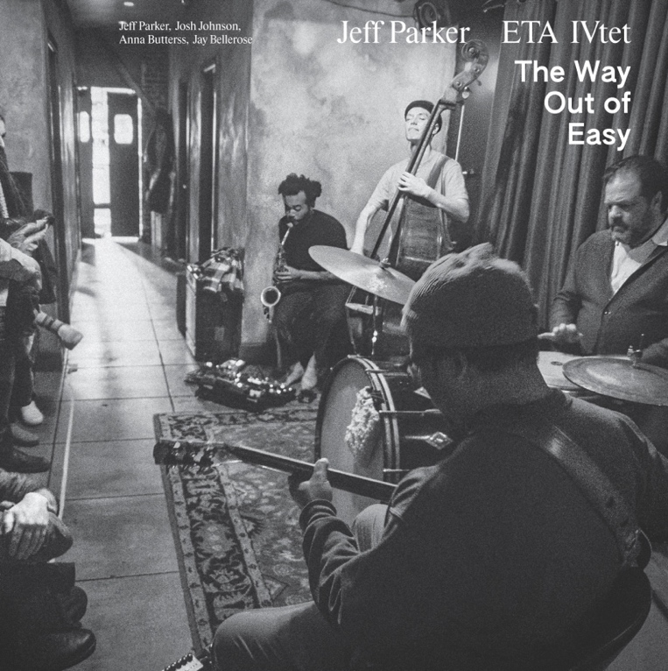
TRACKLIST
Freakadelic
Late Autumn
Easy Way Out
Chrome Dome
CREDITS
ETA 4tet is:
Anna Butterss - amplified double bass
Jay Bellerose - drums, cymbals and percussion
Josh Johnson - amplified alto saxophone with electronics
Jeff Parker - electric guitar with electronics and sampler
All compositions by the ETA IVtet except “Freakadelic” by Jeff Parker (Umjabuglafeesh Music - BMI)
Live recording by Bryce Gonzales at ETA, Highland Park, Los Angeles, California on January 2nd, 2023
Album design by Jeremiah Chiu
Album photography by David Haskell
Liner notes composed by Bryce Gonzales
Mastering by Dave Cooley at Elysian Masters
Thanks to: Bryce and Highland Dynamics, Scottie, David, Dave, Jocelyn and King Hippo at IARC, David Bither and staff at Nonesuch Records, Michael Ehlers, Gerard Lollie (rest in peace), David Haskell, all the artists, musicians and patrons that supported us during our residency at ETA, and to Ryan Julio for giving us a home to explore for seven years. Music heals.
Jeff Parker and ETA IVtet LIVE DATES

ABOUT JEFF PARKER & ETA IVtet
Led by guitarist Jeff Parker, featuring saxophonist Josh Johnson, bassist Anna Butterss, and drummer Jay Bellerose, the ETA IVtet is a band that grew out of a weekly residency started by Parker in 2016 at Northeast Los Angeles venue ETA.
Over seven years of holding down that residency, Parker’s ETA ensemble evolved from a band that played mostly standards into a group known for its transcendent, long-form (sometimes stretching out for 45 minutes or more) journeys into innovative, often uncharted territories of groove-oriented, painterly, polyrhythmic, minimalist and mantric improvised music.
With that musical growth, the crowds for Parker and his band at ETA grew across the years too. What started as a sparse gathering of weeknight drinkers, friends, family, and Chicago expats (coming to get a shot of nostalgia for the atmospheres Parker used to create at Rodan across the ‘00s and early ‘10s) grew into a Los Angeles nightlife staple with a packed house and a line of down the block for every show.
It certainly helped that the renown and résumé of every musician in the ensemble grew significantly between 2016 and 2023. Parker and Bellerose were already well-established veterans in 2016 – the former for his work with Tortoise, Chicago Underground, Isotope 217, and myriad recording dates under his own name; the latter for a huge sideman CV including work with Allen Toussaint, Robert Plant, and Joe Henry – but Butterss and Johnson were relative newcomers in the early days. Butterss has since become a high-tier first-call bassist, playing with the likes of Jason Isbell, Phoebe Bridgers, Makaya McCraven, and Madison Cunningham; while Johnson has run the gamut of studio and live work, notably doing an extended stint as Leon Bridges musical director, and producing Meshell Ndegeocello’s Grammy winning 2023 album The Omnichord Real Book.
Also in that time Butterss released a solo debut and a followup (Activities in 2022 and Mighty Vertebrate in 2024), Johnson a debut and a followup (Freedom Exercise in 2020 and Unusual Object in 2024), and Parker released a run of critically acclaimed albums: The New Breed (2016), Slight Freedom (2016), Suite for Max Brown (2020), Forfolks (2021), and Mondays at the Enfield Tennis Academy (2022).
Mondays introduced the world to Parker and the ETA IVtet’s signature sound, chronicling their distinct, expansive approach to improvisation with a gathering of unnamed side-length tracks recorded and mixed live at ETA by engineer Bryce Gonzales between 2019 and 2021. The album was named “Best New Music” by Pitchfork, where writer Daniel Felsenthal said: “Mondays amounts to something novel in 2022: It lays out long-form spiritual jazz, knotty melodies, and effortless solos over a slow-moving foundation as consistent as an 808. The results are as mesmerizing as a luxurious, beatific ambient record—yet at the same time, it’s clear that all of this is happening within the inherently messy confines of an improvisatory concert.”
In December 2023, just days before ETA permanently shuttered, Parker and the band played at the venue for the last time. In July 2024, the ETA IVtet gathered to perform together for the first time since then, playing for a sold-out crowd of several hundred listeners at Zebulon in Los Angeles. The space may be gone but its spirit lives and the music moves forward into new vessels.
For all PR inquiries, please contact
james@twntythree.com + grace@twntythree.com

Follow International Anthem
Website / Instagram / Youtube / Bandcamp

