
DEVENDRA BANHART’s
NEW ALBUM MA IS OUT TODAY

NEW VIDEO FOR SINGLE “TAKING A PAGE,” FILMED IN NEPAL, ALSO DEBUTS TODAY

TOUR BEGINS SEPTEMBER 27 AT OHANA FESTIVAL, CA

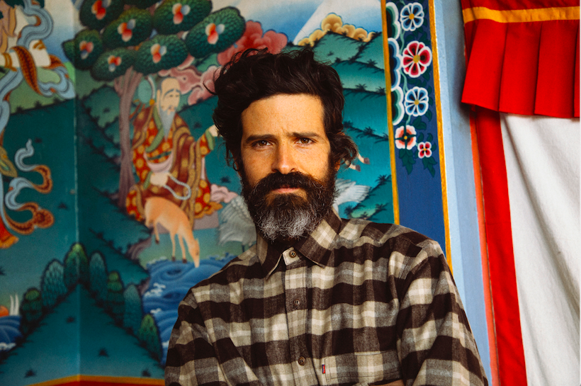
(Credit: The Bardos | Download high res HERE)

"There is a truth and authenticity to the songs here—not because they're autobiographical (though some clearly are) but via their warmth and generosity. These are vignettes of lived experience, rather than whimsical fantasy ... Groovy and moving, in all the right directions. 4 Stars” —MOJO

"Venezuelan/American songwriter Devendra Banhart's singular world remains as intoxicating as ever on the earthy, analogue-sounding ‘Ma’. With lyrics in English, Spanish, Portuguese and Japanese, it feels as if all human life is here ... it's a starkly human moment from a man more often known for his dreamy impishness. 4 Stars” —Q Magazine

“A continuation of his sublimely understated, border-blurring folk rock.” —Los Angeles Times
“Though it’s certainly an intimate record, Ma retains few other markers of his eclectic origins, emphasizing instead the most cohesive songs and sophisticated arrangements that Banhart has delivered to date. It’s a chamber-pop record, full of string arrangements and woodwinds alongside acoustic guitars, bass and drums … even on a collection of highly structured songs with little room for improvisation, Banhart remains the distinctive artist he’s always been.” —Paste

“The subtly autobiographical album presents intertwining themes of motherhood, global politics, life and death through several different tonal lenses, ranging from lighthearted to melancholic and somber. With songs in English, Spanish, Portuguese and Japanese, the album is more tender, emotional and personal than any of his previous work.” —American Songwriter

“Ma, is a tender, beautiful meditation on the bonds that ties us together ... The organic sophistication of the instrumentation purposely recalls the work of Burt Bacharach, Harry Nillson, and Leonard Cohen ... While many of the songs on Ma offer serious meditations about what life is all about, Banhart understands the importance of both joy and pain.” –Popmatters

Devendra Banhart’s eagerly anticipated new album, Ma, is out today on Nonesuch Records and has been praised by critics as his most personal and moving album to date. Banhart marks the release by debuting a new video for his Carole King-inspired album track, “Taking a Page.” Filmed by The Bardos during Devendra’s recent trip to Nepal. Devendra says of the video:

“See my brains ooze out in this Trekker friendly music video for “Taking a Page.” Filmed in Nepal. More specifically in Kathmandu, Muktinath, Ranipauwa, Pokhara, and a few remote parts of upper and lower Mustang. In it you will find:

My monk friend Moti doing make up for the first time...
Neten Chockling Rinpoche liberating a few yaks (roam free wild sisters and hermanos!)
Lindsay from the Bardos!
A bloody shower!
Boudanath Stupa!
Sky Caves!
The chords to Iced Honey by Metallica and Lou Reed
Free Jazz

Ultimately , This is a love letter to Nepal! A land of truly mystical proportions that must be experienced!”

Ma also includes previously released singles “Kantori Ongaku” (“Country Music”), “Abre Los Manos” (“Open Your Hands”), and “Memorial”; the complete track list is below.

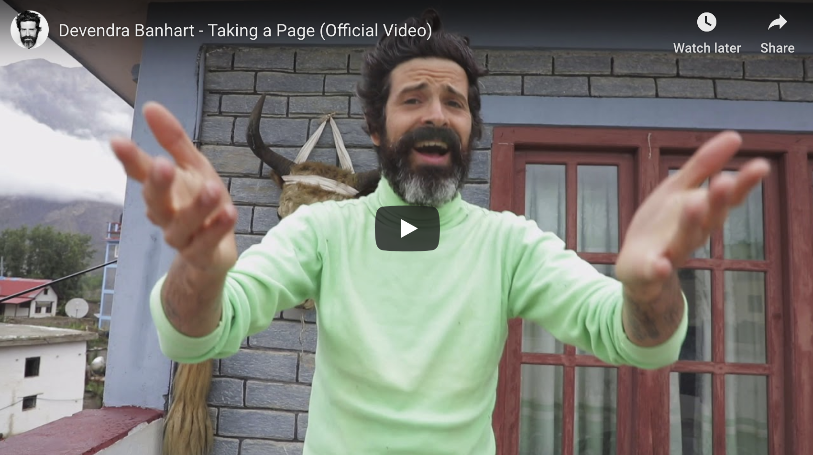

Describing the genesis of the song—for which he sought special permission from Carole King to lift a line and melody from her beloved 1971 classic “So Far Away,” Banhart says, “I’m not sure what ‘Taking a Page’ is about, at least I’m not sure of how to synthesize it into something pithy. I definitely know it’s about how much I can’t stand car chases and those long drawn-out guitar solos (though I’ve certainly been guilty of plenty of ‘em!). I do remember the night Trump won—the shock and fear. I instinctively reached for a Carole King album. I knew it would help. I knew it would come in handy … and it did. Still does. I’m so glad Carole got to hear it. It’s really just a song about my entire life. I can’t explain it much beyond that.”

Carole King’s immediate response upon hearing the song? “I like it.”

Banhart will begin an extensive North American tour on September 27 at Ohana Festival in Dana Point, CA. This twenty-six-date run of shows is his first tour of North America since 2017. Banhart has also confirmed new European dates for early 2020. Ticket information can be found here.

For his US tour, Banhart is partnering with PLUS1 so that $1 from every ticket sold in the US will go to World Central Kitchen (WCK), an organization founded by Nobel Peace Prize–nominated chef José Andrés to fight hunger around the world. WCK is currently responding to the crisis on the Colombia-Venezuelan border and has served more than 350,000 meals to date.

Devendra Banhart Tour Dates:
09/27/19 - Dana Point, CA @ OHANA Festival
10/15/19 - Ventura, CA @ The Majestic Ventura Theater ^
10/16/19 - San Francisco, CA @ The Fillmore ^
10/18/19 - Portland, OR @ Crystal Ballroom ^
10/19/19 - Seattle, WA @ Moore Theatre ^
10/20/19 - Eugene, OR @ WOW Hall !
10/22/19 - Berkeley, CA @ The UC Theatre #
10/24/19 - Los Angeles, CA @ The Theatre at Ace Hotel # @
10/25/19 - Santa Ana, CA @ The Yost Theater #
10/26/19 - San Diego, CA @ The Observatory North Park #
10/27/19 - Phoenix, AZ @ Crescent Ballroom !
10/30/19 - Boulder, CO @ Boulder Theater *
11/01/19 - Omaha, NE @ The Slowdown *
11/02/19 - Minneapolis, MN @ Varsity Theater *
11/03/19 - Chicago, IL @ Thalia Hall *
11/05/19 - Memphis, TN @ The Hi Tone *
11/07/19 - Austin, TX @ Stubbs (Levitation)
11/23/19 - Leon, Guanajuato Mx @ Tecate Bajio Festival
11/25/19 - Mexico City, Mx @ El Plaza Condesa
11/30/19 - Detroit, MI @ Museum of Contemporary Art *
12/01/19 - Toronto, ON @ Danforth Music Hall *
12/03/19 - Montreal, QC @ The Olympia *
12/04/19 - Boston, MA @ The Wilbur *
12/05/19 - Brooklyn, NY @ Brooklyn Steel *
12/07/19 - Washington, D.C. @ 930 Club *
12/08/19 - Philadelphia, PA @ Union Transfer *
1/22/20 Warsaw, Poland @ Palladium
1/24/20 Berlin, Germany @ Tempodrom
1/25/20 Prague, Czech Republic @ Palac Akropolis
1/26/20 Leipzig, Germany @ Felsenkeller
1/28/20 Brussels, Belgium @ Ancienne Belgique (Flex)
1/29/20 Cologne, Germany @ Carlswerk
1/30/20 Amsterdam, Netherlands @ Paradiso
2/1/20 Rotterdam, Netherlands @ Annabel
2/2/20 Nijmegen, Netherlands @ Doornroosje
2/4/20 London, UK @ Shephard's Bush Empire
2/5/20 Paris, France @ Salle Pleyel
2/8/20 Zurich, Switzerland @ X-Tra
2/9/20 Milan, Italy @ Teatro Dal Verme
2/11/20 Madrid, Spain @ Sala Riviera
2/12/20 San Sebastian, Spain @ Teatro Victoria Eugenia
2/13/20 Barcelona, Spain @ Razzmatazz
2/15/20 Porto, Portugal @ Hard Club
2/16/20 Lisbon, Portugal @ Capitolio

* w/ Black Belt Eagle Scout
^ w/ Daniel Higgs
# w/ Cola Boyy
@ w/ Kate Berlant
! w/ Rogov

***
More praise for Devendra Banhart:

"Mr. Banhart is a gifted fantasist, creating spider webs of acoustic guitar and vocals."
- New York Times

"An accomplished shaper of moods and atmosphere."
- Uncut

"One of the most magnetic performers around."
- Guardian

"Banhart's chief talent has always been to write endearing songs."
- Q Magazine

"A Devendra Banhart album is akin to an art exhibit of miniatures, the rewards contingent on the viewer's/listener's commitment to exploring each tiny detail in his microcosmic mise-en-scènes. Those rewards here more often are moments of smiling "ahhhhs" than of wide-eyed "A-has!"
- Los Angeles Times

"He's a singularly idiosyncratic and brilliant songwriter"
- Under the Radar

"Compared to other folk artists, Banhart always manages to feel unbelievably present, like he's performing in the next room over."
- The Line of Best Fit

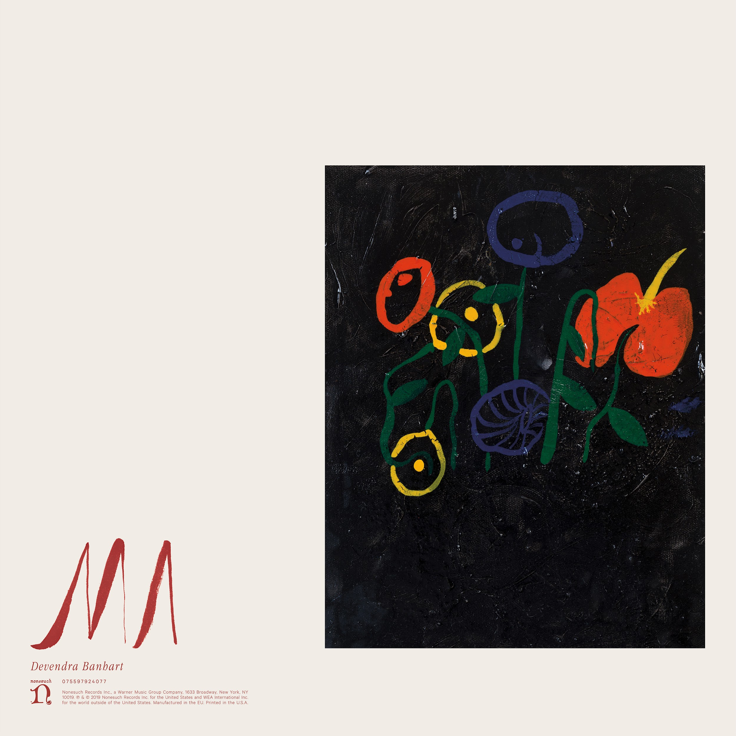
(Download Hi-Res Album Art Here)

Ma Tracklisting:
1. Is This Nice?
2. Kantori Ongaku
3. Ami
4. Memorial
5. Carolina
6. Now All Gone
7. Love Song
8. Abre Las Manos
9. Taking a Page
10. October 12
11. My Boyfriend's In The Band
12. The Lost Coast
13. Will I See You Tonight? (featuring Vashti Bunyan)

Keep Up With Devendra Banhart:
Website | Facebook | Twitter | Instagram | Spotify| YouTube

For more information on Devendra Banhart contact Chloe Walsh or Shane Greenberg at Grandstand Media - ChloeW@GrandstandHQ.com / ShaneG@GrandstandHQ.com
Melissa Cusick at Nonesuch - Melissa.Cusick@nonesuch.com
Matthew Rankin at Nonesuch - Matthew.Rankin@nonesuch.com

