TORTOISE RELEASE OGANESSON REMIXES

FIVE NEW TAKES ON THEIR RECENT SINGLE BY SAUL WILLIAMS, HEBA KADRY, PATRICK CARNEY (THE BLACK KEYS), BROKEN SOCIAL SCENE & MAKAYA MCCRAVEN

DIGITAL EP OUT NOW, VINYL VERSION IN STORES SEPTEMBER 5

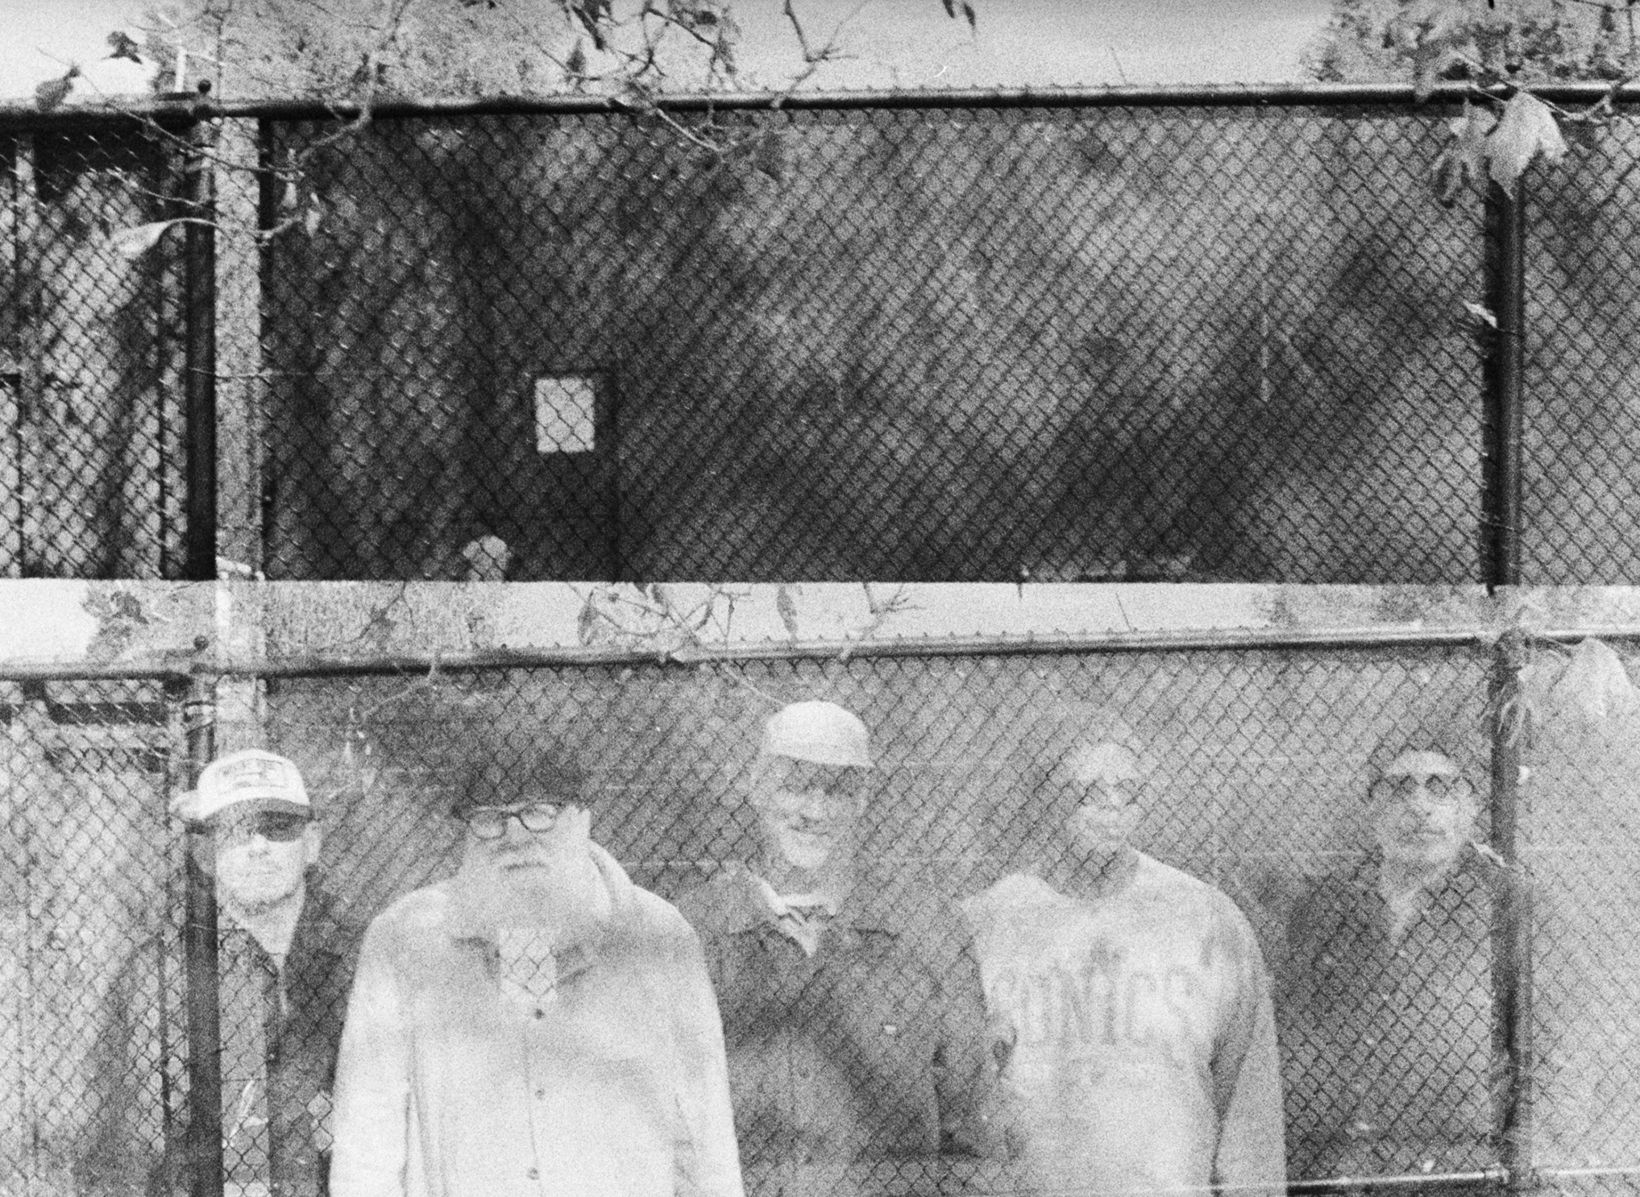
Photo by Todd Weaver
DOWNLOAD ASSETS

Today, Tortoise share Oganesson Remixes, an EP containing five remixes of their recently-released single “Oganesson.” The EP is out now on all digital music platforms, and available on vinyl in stores worldwide September 5th.
Listen to and preorder Oganesson Remixes here.
The Oganesson Remixes EP follows the March 2025 release of the “Oganesson” digital single, which was the first new music released by Tortoise since 2016. The EP includes the original version of “Oganesson” alongside five new remixes of the track created by collaborators and friends of the band, including poet and activist Saul Williams, prolific mastering engineer Heba Kadry, Black Keys drummer Patrick Carney, indie music icons Broken Social Scene, and International Anthem labelmate Makaya McCraven. The Oganesson Remixes EP comes ahead of a new album by Tortoise, which will be released this fall via International Anthem and Nonesuch Records.

Oganesson Remixes is out now, listen to it here.
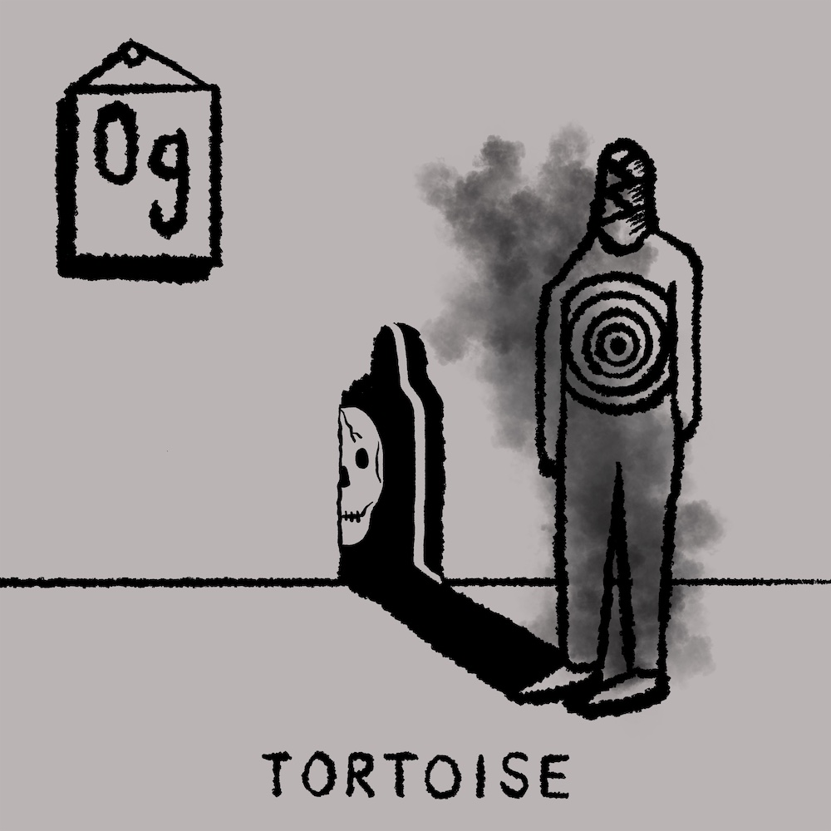
cover art for Oganesson Remixes by John Herndon
TRACKLIST
Oganesson (original version)
Oganesson (Saul Williams Remix)
Oganesson (Heba Kadry Remix)
Oganesson (Patrick Carney Remix)
Oganesson (Broken Social Scene Remix)
Oganesson (Makaya McCraven Remix)
Stay connected with Tortoise:
Website | Instagram | Facebook
Stay connected with International Anthem:
23 Profile | Website | Facebook | Instagram | YouTube

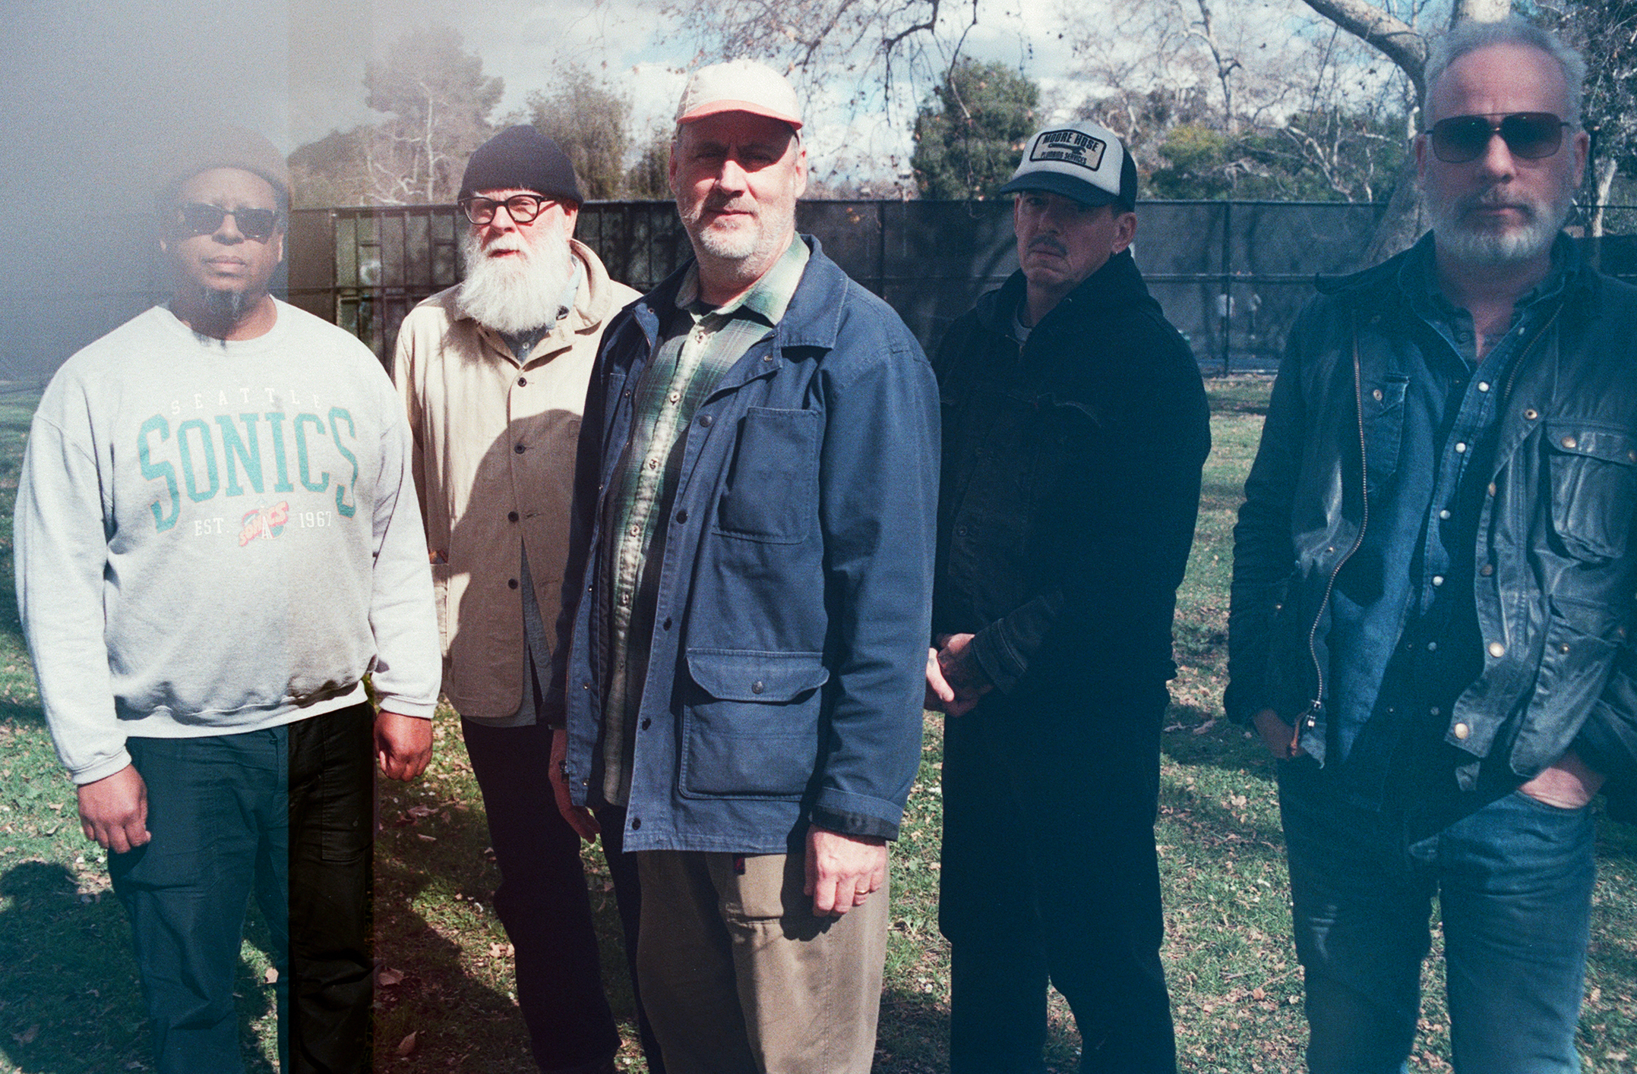
ABOUT TORTOISE

Tortoise is widely considered one of the most influential music groups of the last 40 years, with a wide-reaching impact on the contemporary music scene. Pitchfork says: “Imagine a graphic showing all the bands the five members of Tortoise were in before they came together and then all the bands they went on to play with after. At the top of the funnel you have groups ranging from dreamy psych-rock to earthy post-punk crunch, including Eleventh Dream Day, Bastro, Slint, and the Poster Children; on the 'post-Tortoise' end are groups focusing on electro-jazz and twangy instrumental rock like Isotope 217, Chicago Underground, and Brokeback. In this graphic, Tortoise is the choke point, the one project that has elements of all these sounds but is never defined by nor committed to any of them. Instead, Tortoise floats free, a planchette moving over a Ouija board guided by 10 sets of fingers, where everyone watches the arrow float in one direction but no one is quite sure how it gets there or who is doing the pushing.”
The band, which originally formed in Chicago, comprises Jeff Parker, Dan Bitney, Douglas McCombs, John Herndon, and John McEntire.
Initially hailed as pace-setters of the then-emerging, so-called “post-rock” sound, the Chicago Tribune called Tortoise’s sound “mood music that refuses to be shoved into the background, as inviting as it is challenging.” Releasing just seven albums since 1990 — including classics like 1996’s Millions Now Living Will Never Die, 1998’s TNT, and 2001’s Standards —Tortoise has steadily and intuitively evolved across its life, creating genreless music that is as timeless as it is ahead of the curve.
The band’s legacy goes beyond its recorded output, as well. Per the New York Times: “While Tortoise's albums have experimented with the editing and overdubbing possibilities of the studio, the band thrives performing in real time.” Rolling Stone deems Tortoise “a live marvel,” while Pitchfork further says the band’s performances reveal that “at heart, they’re a supremely fun band, wide open to all sorts of sonic possibilities.”

For all PR inquiries, please contact
james@twntythree.com + grace@twntythree.com

